**[](https://bit.ly/3v3m6Eu)COMMERCIAL CONSTRUCTION**

**MANAGEMENT PLAN**

**TEMPLATE**

PROJECT NAME

MANAGEMENT PLAN

COMPANY NAME

Street Address

City, State and Zip

webaddress.com

Version 0.0.0

00/00/0000

Table of Contents

1. EXECUTIVE SUMMARY 3

2. SITE DESCRIPTION 4

3. SCOPE 5

3.1 DELIVERABLES 5

3.2 WORK BREAKDOWN STRUCTURE (WBS) 5

3.3 ROLES AND RESPONSIBILITIES 6

3.4 SCHEDULE BASELINE 7

3.5 MILESTONE LIST 7

4. COMMUNICATION MANAGEMENT PLAN 8

5. RESOURCE MANAGEMENT PLAN 9

6. SCHEDULE 10

7. BUDGET 11

8. BIDS AND CONTRACTS 12

8.1 BID TABULATION 13

8.2 ABSTRACT OF BIDS 14

8.3 SUBCONTRACTOR DOCUMENTATION 15

8.4 DAILY / WEEKLY INSPECTION REPORT 16

8.5 CONTRACTOR PROGRESS PAYMENT 17

9. CONSTRUCTION DOCUMENTS 18

10. PLANNING AND PERMISSIONS 19

11. RISK MANAGEMENT PLAN 20

11.1 RISK REGISTER 21

12. CONSTRUCTION PUNCH LIST 22

13. PROJECT CLOSEOUT CHECKLIST 23

14. AUTHORIZATION SIGNATURES 24

15. APPENDICES 25

# EXECUTIVE SUMMARY

|  |
| --- |
| Provide an overview of the commercial construction project as well as its objectives and business benefits. |

# SITE DESCRIPTION

|  |
| --- |
| Provide information on the site, including its size, boundaries, neighbors, present use, major features, and soil type. Also, be sure to include any preparation that the site requires in order to be construction ready. |

# SCOPE

|  |
| --- |
| Refer to the commercial construction contract and capture all high-level data, such as budget and technical specifications as well as the targeted completion date. |

## DELIVERABLES

|  |
| --- |
| Identify the project’s deliverables or outcomes. |

## WORK BREAKDOWN STRUCTURE (WBS)

|  |
| --- |
| Discuss how you will use the work breakdown structure to complete the project, and link to the WBS document and WBS dictionary, which, together, detail the work packages and individual tasks for the project. |

## ROLES AND RESPONSIBILITIES

|  |
| --- |
| List the names of the key project stakeholders and individuals involved. Identify the decision makers on the client side as well as the project’s contractors and subcontractors. |

## SCHEDULE BASELINE

|  |
| --- |
| Provide a schedule baseline, so you can gauge progress. |

## MILESTONE LIST

Summarize the major milestones. Then, list each milestone and its date. Describe how to update any changes to the schedule and milestones and how to communicate those changes.

|  |  |  |
| --- | --- | --- |
| MILESTONE | DESCRIPTION | DATE |
|  |  |  |
|  |  |  |
|  |  |  |
|  |  |  |
|  |  |  |
|  |  |  |

# COMMUNICATION MANAGEMENT PLAN

A communication management plan does the following: It identifies the people who need information and updates on the project; it explains the nature of the information they need; it indicates how frequently those people need updates; and it details how to update them. The plan is often used in tandem with a stakeholder list. Outline the **Communication Management Plan** here or link to a separate document.

|  |  |  |  |
| --- | --- | --- | --- |
| NAME | TITLE | EMAIL | OFFICE PHONE |
|  |  |  |  |
|  |  |  |  |
|  |  |  |  |
|  |  |  |  |
|  |  |  |  |
|  |  |  |  |

|  |  |  |  |  |  |
| --- | --- | --- | --- | --- | --- |
| COMMUNICATION TYPE | DESCRIPTION | FREQUENCY | MESSAGE DISTRIBUTION | DELIVERABLE | DELIVERABLE OWNER |
|  |  |  |  |  |  |
|  |  |  |  |  |  |
|  |  |  |  |  |  |
|  |  |  |  |  |  |
|  |  |  |  |  |  |
|  |  |  |  |  |  |

# RESOURCE MANAGEMENT PLAN

|  |
| --- |
| Procurement management should include all resources, equipment, and supplies. It should also indicate  whether your company will purchase or rent goods or services. You can use Smartsheet’s **Construction Project Resource Management Template** to provide the following information regarding each job:   * Type of activity, such as laying foundation * Start date/duration of activity * Activity or task owner * Necessary labor and specialized skills * Necessary quantity of each resource type * Source of each resource type (internal and/or third party/subcontractor and their physical location, contact person, and contact details) * Necessary hours for completion of activity * Controller (such as supervisor) * Necessary materials and their source * Necessary equipment and its source * Cost estimate for each resource/material/piece of equipment * Assumptions (for example, cost estimate not yet confirmed) * Alternative if resources are unavailable   Table  Description automatically generated |

# SCHEDULE

|  |
| --- |
| Smartsheet’s **Construction Project Timeline Template** gives you a broad overview of the schedule. It also lets you include a detailed breakdown of project task start and end dates. |

# BUDGET

|  |
| --- |
| Smartsheet’s **Construction Budget Template** gives you a broad overview of the budget. It also offers entries for hundreds of tasks and a breakdown of labor, materials, and fixed costs per line item. |

# BIDS AND CONTRACTS

|  |
| --- |
|  |

## BID TABULATION

## ABSTRACT OF BIDS

## SUBCONTRACTOR DOCUMENTATION

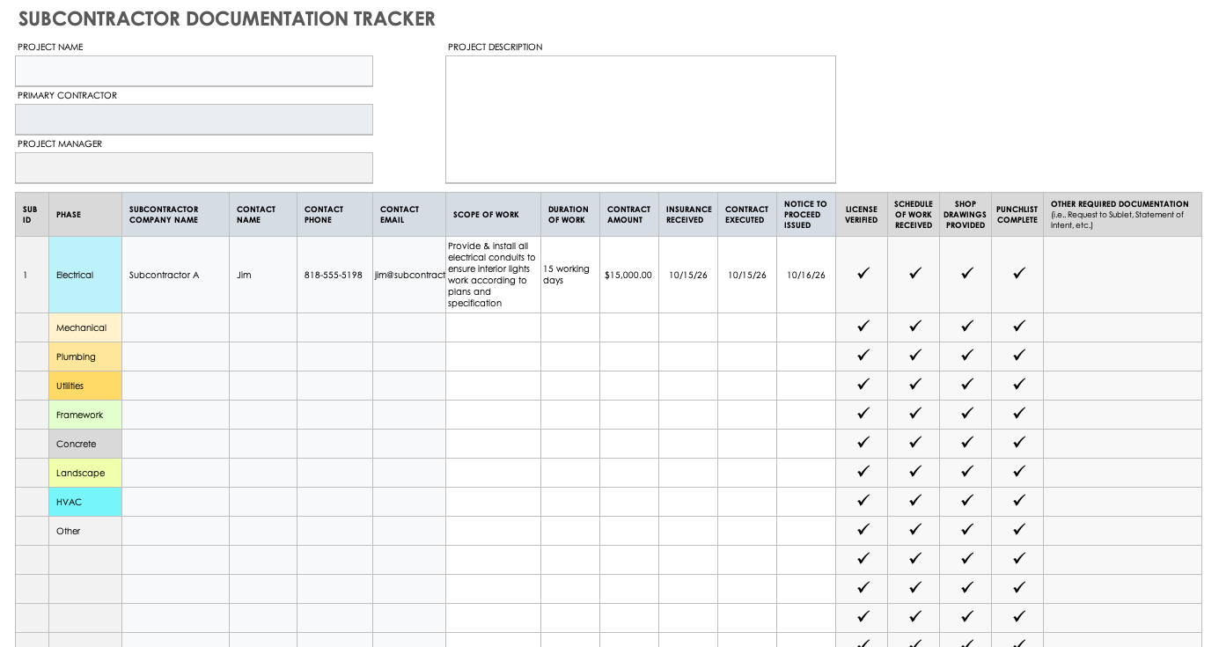

## DAILY / WEEKLY INSPECTION REPORT

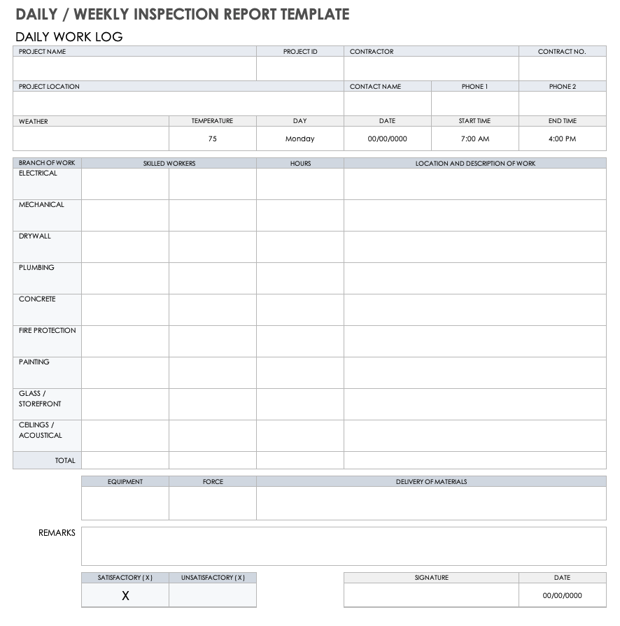

## CONTRACTOR PROGRESS PAYMENT

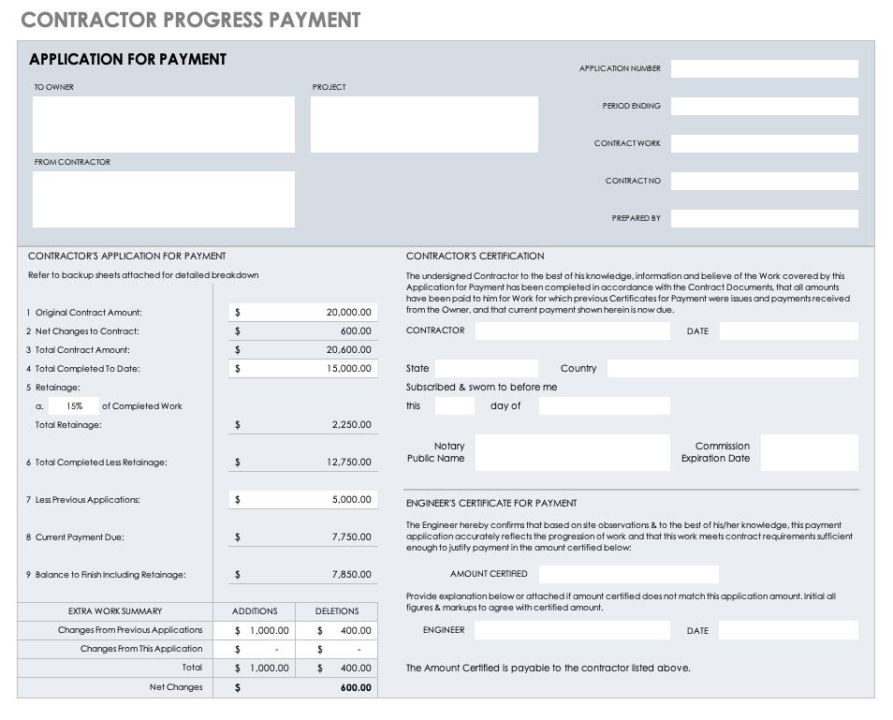

# CONSTRUCTION DOCUMENTS

|  |
| --- |
| Attach or provide links to your plans, renderings, specifications, and schematics here. |

# PLANNING AND PERMISSIONS

|  |  |
| --- | --- |
| STATUS OF CONSTRUCTION PERMIT |  |
| CONTACT INFORMATION |  |
| TASK  OWNER |  |
| SITE  OPERATING HOURS |  |
| PLAN FOR PUBLIC SAFETY AND SITE SECURITY |  |
| NOISE AND VIBRATION MEASURES |  |
| MITIGATION MEASURES FOR AIR, DUST, STORMWATER, AND SEDIMENT |  |
| WASTE MANAGEMENT |  |
| TRAFFIC MANAGEMENT |  |

# RISK MANAGEMENT PLAN

|  |
| --- |
| Briefly describe how you plan to identify, analyze, and prioritize project risks. Also, describe the methods you plan to use for tracking risks. In addition, delineate your contingency plans. |

## Table Description automatically generatedRISK REGISTER

# CONSTRUCTION PUNCH LIST

|  |
| --- |
| Punch lists help you make sure that you’re meeting all aspects of your contract before starting to wrap up your project. Punch lists also help you avoid the pitfalls of using email and spreadsheets.  Using this **Construction Punch List Template**, you can easily share row or sheet information with collaborators, even if the other party does not have a Smartsheet account. This level of accessibility comes in handy when you’re coordinating with contractors. For example, if an electrical contractor is behind on installing light fittings, they can flag the action item as “at risk,” and you can adjust the project accordingly.  Smartsheet Construction Punch List Template |

# PROJECT CLOSEOUT CHECKLIST

|  |
| --- |
| Once you’re close to finishing your construction project, you need to tie up loose ends and ensure that you’ve met all expectations. For this phase, you need a reliable checklist template that tracks the following:   * Contract closeouts * Workmanship bonds * Required testing * Warranties and guarantees * Certificates * Final submittals   With this **Project Closeout Checklist Template**,you can set up automated alerts so that when a stakeholder or contractor completes a task, you receive an approval request. If you need to do an on-site inspection, you can do so while easily accessing the template through the Smartsheet mobile app.  Smartsheet Project Closeout Checklist Template |

# AUTHORIZATION SIGNATURES

**PREPARED BY**

|  |  |
| --- | --- |
|  | |
| *Name and Title* (printed) | |
|  |  |
| *Signature* | *Date* |

**RECOMMENDED BY**

|  |  |
| --- | --- |
|  | |
| *Name and Title* (printed) | |
|  |  |
| *Signature* | *Date* |

**APPROVED BY**

|  |  |
| --- | --- |
|  | |
| *Project Sponsor Name and Title* (printed) | |
|  |  |
| *Project Sponsor Signature* | *Date* |

# APPENDICES

Attach or link to separate plan documents or other reference documents. *Optional.*

|  |  |
| --- | --- |
| ATTACHMENT NAME | LOCATION / LINK |
|  |  |
|  |  |
|  |  |
|  |  |
|  |  |
|  |  |
|  |  |
|  |  |
|  |  |

ADDITIONAL TEMPLATES

CONSTRUCTION SUBMITTAL FORM TEMPLATE

Use this easy-to-fill template to prepare submittals for general contractor and design team approval of materials and equipment. Enter the submittal’s identification details (e.g., submittal ID, project ID, project name, etc.) and the submittal type (e.g., shop drawing, product data, RFI, etc.), as well as who prepared the submittal. Add architect approval to the document via a submittal review form. This **Construction Submittal Form Template** also includes a built-in construction submittal change order, in case any cost changes arise concerning the project’s initial scope of work.

SCHEDULE OF SUBMITTALS TEMPLATE

Contractors can use this **Schedule of Submittals Template** to ensure that they deliver submittals and projects on time. Easily list submittal items, as well as their timelines, to ensure timely delivery to project managers, engineers, permit issuers, and inspectors. Enter the project ID, name of the project, name of the project manager, contract information, submittal spec section information (including submittal type and description), and projected dates for transmittal, approval, and delivery.

SUBMITTAL LOG TEMPLATE

Contractors can use this **Submittal Log Template** to track every aspect of a submittal, including the item ID, item name, party responsible, date received, date sent, date returned, status (e.g., pending, approved, incomplete-resubmit, etc.), date of status change, copies to, and more. Having comprehensive submittal information at a glance gives you the power to deliver your project on time and within budget.

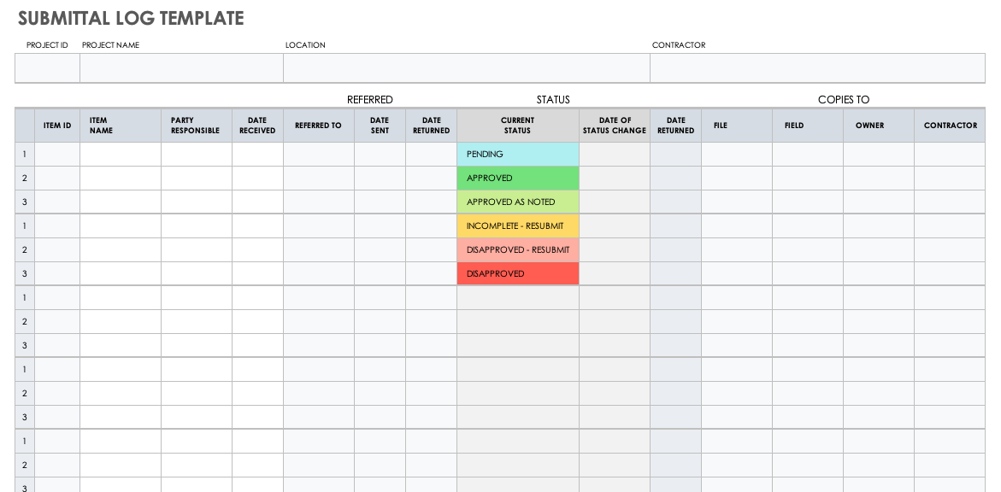

CONSTRUCTION REQUEST FOR INFORMATION TEMPLATE

Contractors and subcontractors use RFIs to get clarification on an issue before proceeding with work. If you need to modify your project’s scope of work, you can often use an RFI and a change order interchangeably. If you need a more formal change request for approval however, you cannot use the two forms interchangeably. In this **Construction Request for Information Template**, contractors can specify a drawing number for reference and indicate possible changes in cost or schedule. This template includes a section at the top for listing the project’s name, location, and other details.

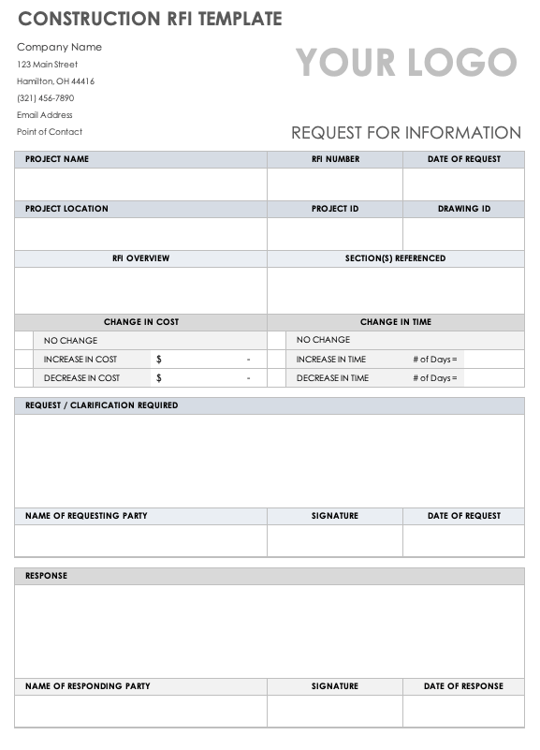

|  |
| --- |
| **DISCLAIMER**  Any articles, templates, or information provided by Smartsheet on the website are for reference only. While we strive to keep the information up to date and correct, we make no representations or warranties of any kind, express or implied, about the completeness, accuracy, reliability, suitability, or availability with respect to the website or the information, articles, templates, or related graphics contained on the website. Any reliance you place on such information is therefore strictly at your own risk. |