PROJECT PLAN BRIEF TEMPLATE

PROJECT NAME
PROJECT MANAGEMENT PLAN

COMPANY NAME
Street Address
City, State and Zip

webaddress.com

Version 0.0.0

00/00/0000

VERSION HISTORY
VERSION | APPROVED BY | REVISION DATE | DESCRIPTION OF CHANGE | AUTHOR

PREPARED BY |  | TITLE |  | DATE
APPROVED BY |  | TITLE |  | DATE

Table of Contents
1. EXECUTIVE SUMMARY 3
2. PROJECT MANAGEMENT APPROACH AND GOVERNANCE 4
2.1 PROJECT SCOPE 4
2.2 DELIVERABLES 5
2.3 WORK BREAKDOWN STRUCTURE (WBS) 5
2.4 STAKEHOLDER ANALYSIS 5
2.5 SCHEDULE BASELINE 6
2.6 MILESTONE LIST 6
2.7 CHANGE MANAGEMENT PLAN 6
2.8 PROJECT SCOPE MANAGEMENT PLAN 7
3. COMMUNICATION MANAGEMENT PLAN 8
4. RESOURCE MANAGEMENT PLAN 9
5. HUMAN RESOURCES MANAGEMENT PLAN 9
5.1 PROJECT STAFF LIST 10
5.2 RESOURCE REQUIREMENT CALENDAR 11
6. SCHEDULE MANAGEMENT PLAN 12
7. QUALITY MANAGEMENT PLAN 12
8. RISK MANAGEMENT PLAN 13
8.1 RISK LOG 13
9. COST BASELINE 14
10. QUALITY BASELINE 14
11. APPENDICES 15
12. AUTHORIZATION SIGNATURES 16

[Template provides a basic outline for a project management plan. Add, delete, rearrange, or adapt the included sections, tables, and calendar as necessary to meet the needs of your organization and project. You can also briefly introduce plans in each section and then link or attach a larger document.]

EXECUTIVE SUMMARY
Use the project charter to summarize the purpose of the project. Detail goals and objectives.

PROJECT MANAGEMENT APPROACH AND GOVERNANCE
Describe the management approach for the project, or link to a governance plan. Detail roles and responsibilities of project team members. List any vendors or other organizations that will provide resources for the project. The governance section may also include assumptions and constraints.

PROJECT SCOPE
Refer to the project charter to define the project scope, or link to the scope of work document. Defining the limits of scope will aid focus and prevent scope creep. If you are a vendor or contractor, refer to the statement of work.

DELIVERABLES
Specify the deliverables or outcomes for the project.

WORK BREAKDOWN STRUCTURE (WBS)
Discuss how the work breakdown structure will be used to complete the project, and link to the WBS document and WBS dictionary, which details the work packages or tasks for the project.

STAKEHOLDER ANALYSIS
Describe how stakeholders were identified and how they will impact and be impacted by the project. If you use a stakeholder analysis matrix, attach it here.

SCHEDULE BASELINE
Provide schedule baseline so that you can gauge progress.

MILESTONE LIST
Summarize the major milestones. Then, list each milestone and its date. Describe how to update any changes to the schedule and milestones and how to communicate those changes.
MILESTONE | DESCRIPTION | DATE

CHANGE MANAGEMENT PLAN
Describe the change control process or link to a separate document. Describe who can submit changes, who approves changes, and how changes are communicated and tracked. If your organization has a standing process or a change control board, refer to any existing documentation.

PROJECT SCOPE MANAGEMENT PLAN
Detail who has the authority to manage project scope, how scope will be measured, and who will approve the final project.

COMMUNICATION MANAGEMENT PLAN
A communication plan defines who needs information and updates on the project, what information they need, how frequently those people must be updated, and how they will be updated. A communication management plan is often used in tandem with a stakeholder list. Outline the plan here or link to a separate document.
NAME | TITLE | EMAIL | OFFICE PHONE

COMMUNICATION TYPE | DESCRIPTION | FREQUENCY | MESSAGE DISTRIBUTION | DELIVERABLE | DELIVERABLE OWNER

RESOURCE MANAGEMENT PLAN
Procurement management can include all resources equipment and supplies. Also, detail whether goods or services will be purchased or rented.

HUMAN RESOURCES MANAGEMENT PLAN
Detail how you will determine staffing needs for the project. Describe necessary skill sets, salary or hourly rates, and any training requirements, if applicable. When positions are filled, include names, titles, and contact information.

PROJECT STAFF LIST
NAME | TITLE | EMAIL | PHONE

RESOURCE REQUIREMENT CALENDAR
A resource calendar details key resources for the project. It describes what resources will be needed when and for how long. Note that not all resources will necessarily be required for the duration. Complete this calendar or link to an external document.
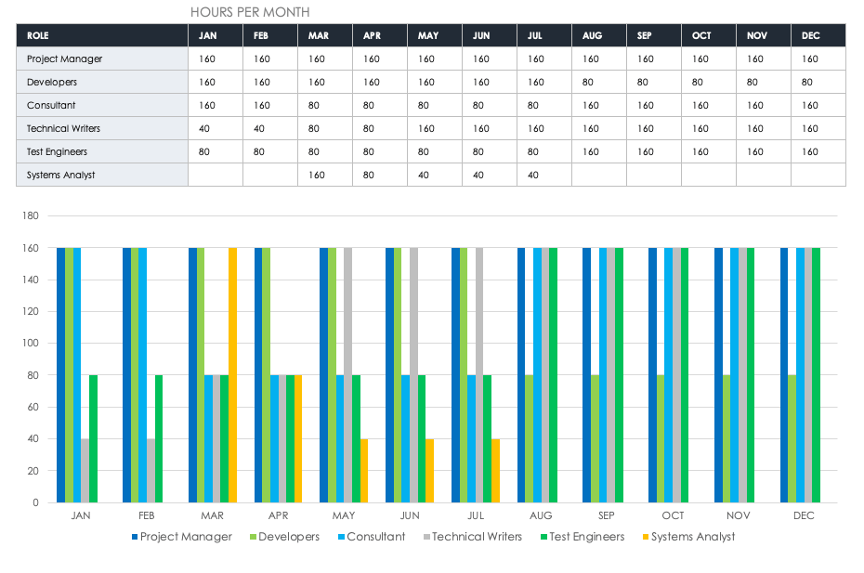

SCHEDULE MANAGEMENT PLAN
Explain methods for developing the schedule and what tools will be used to record and post the schedule and any changes.

QUALITY MANAGEMENT PLAN
Describe the processes that will ensure the quality of deliverables. Define the quality standards, continuous improvement processes, quality governance, metrics, and reporting frequency and methods.

RISK MANAGEMENT PLAN
Briefly describe how you plan to identify, analyze, and prioritize project risks. Also, describe the methods used for tracking risks. Describe contingency plans.

RISK LOG
Link to an external risk log or attach a log as an appendix.

COST BASELINE
Detail the cost baseline for the project. This information provides the basis for tracking, reporting, and managing costs. Complete this table or link to an external document.
PROJECT PHASE | BUDGETED TOTAL | COMMENTS

QUALITY BASELINE
Define the quality baseline for the project, which includes any tolerances or standards. Complete this table or link to an external document.
ITEM | ACCEPTABLE LEVEL | COMMENTS

APPENDICES
Attach or link to separate plan documents or other reference documents. Optional.
ATTACHMENT NAME | LOCATION / LINK

AUTHORIZATION SIGNATURES

PREPARED BY

Name and Title (Printed)
Signature | Date

RECOMMENDED BY

Name and Title (Printed)
Signature | Date

APPROVED BY

Project Sponsor Name and Title (Printed)
Project Sponsor Signature | Date

DISCLAIMER

Any articles, templates, or information provided by Smartsheet on the website are for reference only. While we strive to keep the information up to date and correct, we make no representations or warranties of any kind, express or implied, about the completeness, accuracy, reliability, suitability, or availability with respect to the website or the information, articles, templates, or related graphics contained on the website. Any reliance you place on such information is therefore strictly at your own risk.

