BRAND PARTNERSHIP
STRATEGY TEMPLATE

BRAND PARTNERSHIP STRATEGY
DOCUMENT TITLE /
HEADING

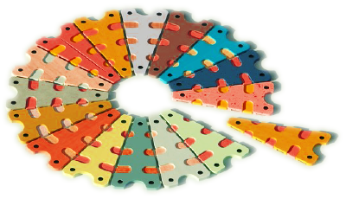
PREPARED BY
PREPARER NAME

00/00/0000

Table of Contents
JOINT VALUE PROPOSITION SUMMARY 3
IDEA / PROPOSAL 4
TARGET MARKET 5
MARKET OPPORTUNITIES 5
IDEAL CUSTOMER PERSONA 5
SALES STRATEGY 6
INVESTMENT & ROI 7

JOINT VALUE
PROPOSITION
SUMMARY

IDEA /
PROPOSAL

TARGET
MARKET

MARKET OPPORTUNITIES

IDEAL CUSTOMER PERSONA

SALES
STRATEGY

INVESTMENT
& ROI

DISCLAIMER

Any articles, templates, or information provided by Smartsheet on the website are for reference only. While we strive to keep the information up to date and correct, we make no representations or warranties of any kind, express or implied, about the completeness, accuracy, reliability, suitability, or availability with respect to the website or the information, articles, templates, or related graphics contained on the website. Any reliance you place on such information is therefore strictly at your own risk.

