BRAND PERSONA
WORKSHEET

Company Name

brand manager
brand manager NAME

00/00/0000

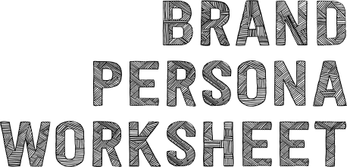
Table of Contents
Company Overview 3
Your Brand as a Person 4
This, But Not That 6
Brand Affiliations and Beliefs 7
Brand Voice 8
Visual Identity 9
Colors 9
Typography 10
Logo 10

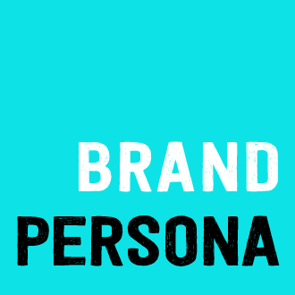
Company
Overview

Write a brief summary of what your company does and for whom.

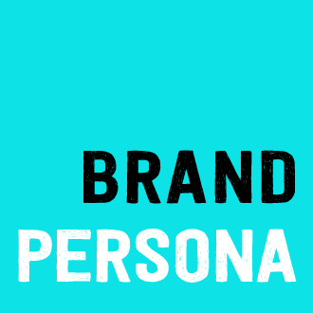
Your Brand
as a Person

Write a description of who your brand would be if it were a person. Choose a few adjectives that clearly describe this individual. Include a photograph to help visualize a person who represents your brand.
35
Seattle
Media Manager
$85k
Gloria Miner
Single
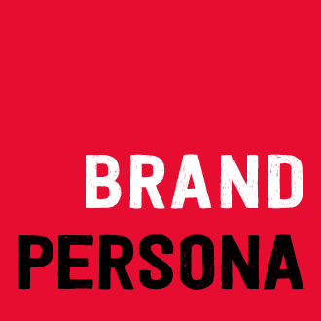
Brand Personality Traits

Rank your brand based on which traits best describe and are most important to the brand. Apply a score of 1 to 10 to each trait with 10 being the most important.

TRAIT | SCORE |  | TRAIT | SCORE |  | TRAIT | SCORE
Accessible |  |  | Exclusive |  |  | Sophisticated
Altruistic |  |  | Feminine |  |  | Spirited
Authoritative |  |  | Friendly |  |  | Spiritual
Bold |  |  | Fun |  |  | High Tech
Caring |  |  | Masculine |  |  | Low Tech
Clever |  |  | Mature |  |  | No Tech
Competent |  |  | Modern |  |  | Traditional
Conservative |  |  | Personable |  |  | Warm
Corporate |  |  | Polished |  |  | Worldly
Dependable |  |  | Professional |  |  | Youthful
Easy-Going |  |  | Quirky
Edgy |  |  | Rebellious
Elegant |  |  | Rugged
Established |  |  | Serious
Exciting |  |  | Sincere

TOP 5 TRAITS | TRAIT 1 | TRAIT 2
TRAIT 3 | TRAIT 4 | TRAIT 5

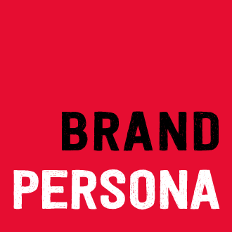
This,
But Not That

Choose adjectives that describe your key brand characteristics. Example: emotive but not sensational. At the end of the exercise, choose the top two phrases that reflect your brand in order to hone your messaging and brand representation.

This, but not that.
but not
but not
but not
but not
but not
but not
but not
but not
but not
but not

TOP 2 PHRASES | Phrase 1
 | Phrase 2

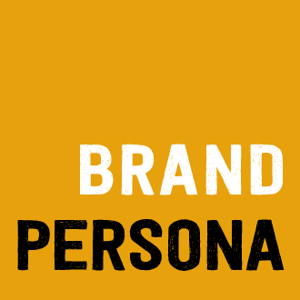
Brand Affiliations
and Beliefs

What causes (political, social, religious, etc.) are your brand affiliated with?
What is your brand’s relationship to these causes?
How does your ideal customer view your beliefs?
Are these beliefs and affiliations relevant to your public branding strategy?

Brand
Voice

How do you want your brand to make people feel?
What other brand has a similar voice?
What voice would not appeal to your target audience?
Who would your brand be if it were a celebrity?
What makes your voice different from your competition?

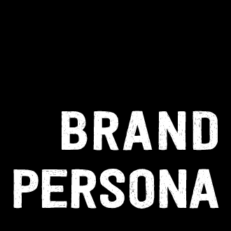
Visual
Identity

How is your brand personality represented visually?

Colors

Typography

Logo

DISCLAIMER

Any articles, templates, or information provided by Smartsheet on the website are for reference only. While we strive to keep the information up to date and correct, we make no representations or warranties of any kind, express or implied, about the completeness, accuracy, reliability, suitability, or availability with respect to the website or the information, articles, templates, or related graphics contained on the website. Any reliance you place on such information is therefore strictly at your own risk.

