BRAND PYRAMID MEETING

EMAIL TEMPLATE

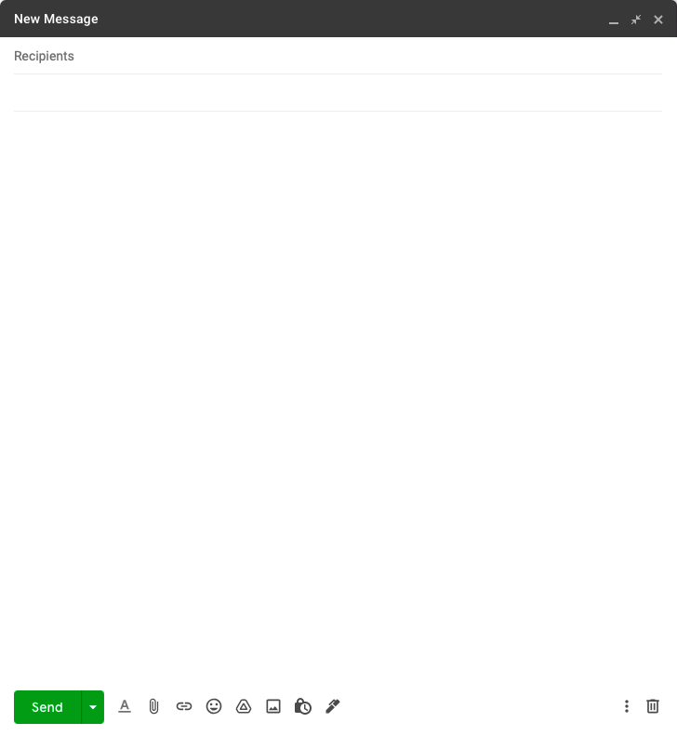
Brand Pyramid Meeting
Hi Team,

As our rebrand approaches, I would like to take this opportunity to invite you to our Brand Pyramid Meeting on 00/00/0000 at 00:00 am/pm.

Come early for light refreshments, and be ready to dive right in! We’ll spend our time:
- Reviewing our current branding approach
- Workshopping areas that need improvement
- Putting together a first draft brand pyramid

We are very excited about this new brand pyramid and can’t wait to gather your input and ideas. Please come prepared by considering the following:

- What makes our brand stand out from the competition?
- What words and feelings come to mind when you think about our brand?
- How would you describe our brand’s personality?
- What are our core values as a brand? (Consider our mission statement.)
- What are our most well-known and successful product offerings?

Please respond to this invite by 00/00/0000. If you cannot attend, please send us an email with your responses to the questions above, so we can include your input at the meeting.

Thank you,
Management

DISCLAIMER

Any articles, templates, or information provided by Smartsheet on the website are for reference only. While we strive to keep the information up to date and correct, we make no representations or warranties of any kind, express or implied, about the completeness, accuracy, reliability, suitability, or availability with respect to the website or the information, articles, templates, or related graphics contained on the website. Any reliance you place on such information is therefore strictly at your own risk.

