BRAND STRATEGY PLANNING TEMPLATE

BRAND
STRATEGY

Brand Name

BRAND MANAGER NAME
BRAND MANAGER

00/00/0000

Table of Contents
BRAND PURPOSE 3
CORE VALUES 4
BRAND VISION 5
BRAND MISSION 6
TARGET AUDIENCE 7
BUYER PERSONAS 8
COMPETITOR ANALYSIS 9
UNIQUE VALUE PROPOSITION 10
BRAND POSITION 11
BRAND MESSAGING 12
BRAND IMAGERY 13

BRAND PURPOSE

CORE VALUES

BRAND VISION

BRAND MISSION

TARGET AUDIENCE

BUYER PERSONAS
 | PERSONA 1 | PERSONA 2
Age
Gender
Relationship Status
Occupation
Income
Information Sources
Goals and Values
Challenges and Pain Points
How Your Brand Solves Their Problems

COMPETITOR ANALYSIS
Brand Name
Brand Purpose
and Values
Unique Value Proposition
Tagline
Target Audience
Core Products
Marketing Channels
Strengths
Weaknesses
Other

UNIQUE VALUE PROPOSITION

BRAND POSITION

BRAND MESSAGING
Voice and
Tone
Taglines
Other Phrases

BRAND IMAGERY
Logo
Colors | 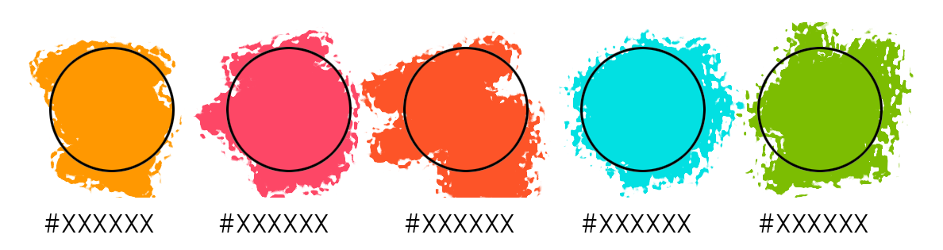

Visual Style
Typography | 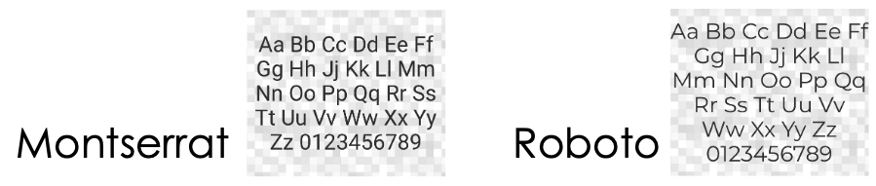

DISCLAIMER

Any articles, templates, or information provided by Smartsheet on the website are for reference only. While we strive to keep the information up to date and correct, we make no representations or warranties of any kind, express or implied, about the completeness, accuracy, reliability, suitability, or availability with respect to the website or the information, articles, templates, or related graphics contained on the website. Any reliance you place on such information is therefore strictly at your own risk.

