CONSTRUCTION PROJECT PLAN TEMPLATE

PROJECT TITLE |  |  |  | START | END

PROJECT MANAGER |  |  |  | PROJECT DURATION IN DAYS

Note: Take screen shot of this template in the Excel version for the GANTT snapshot below and insert the image onto this cover page. Full project plan template table is on Page 2 of this template.

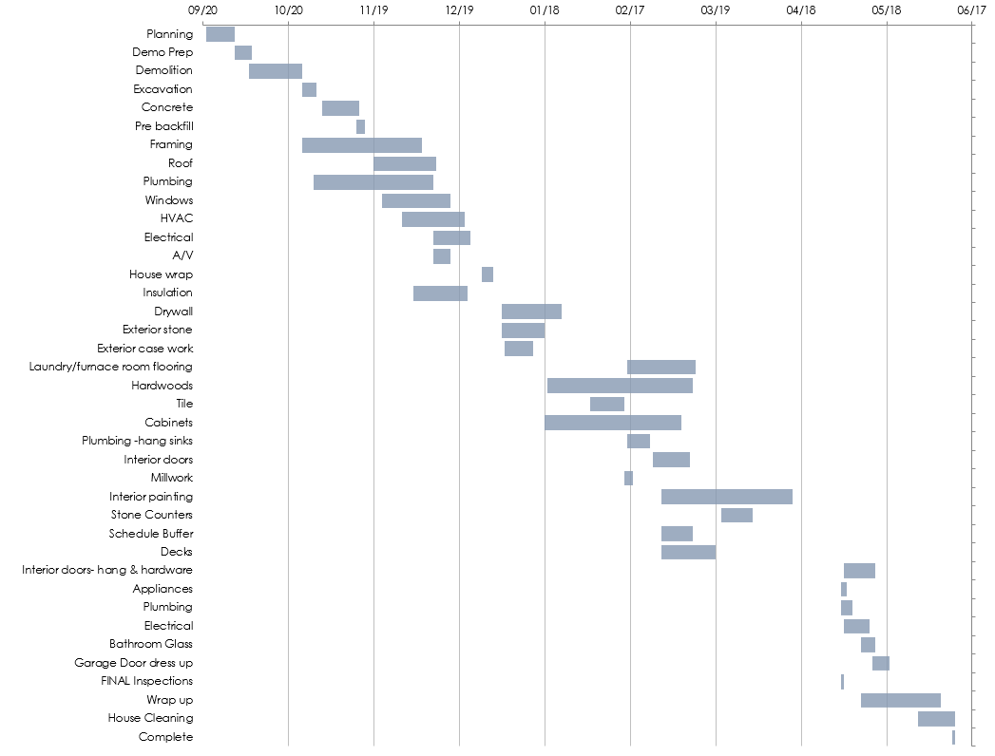
TASK NAME | STATUS | ASSIGNED TO | START DATE | END DATE | DURATION in days | COMMENTS
Planning | In Progress
Demo Prep | Not Started
Demolition | Complete
Excavation | On Hold
Concrete | In Progress
Pre backfill | Complete
Framing | In Progress
Roof | Needs Review
Plumbing | Needs Review
Windows | On Hold
HVAC | Not Started
Electrical | Not Started
A/V | In Progress
House wrap | In Progress
Insulation | On Hold
Drywall | In Progress
Exterior stone | In Progress
Exterior case work | In Progress
Laundry/furnace room flooring | In Progress
Hardwoods | In Progress
Tile | In Progress
Cabinets | In Progress
Plumbing -hang sinks | In Progress
Interior doors | In Progress
Millwork | In Progress
Interior painting | In Progress
Stone Counters | In Progress
Schedule Buffer | In Progress
Decks | In Progress
Interior doors- hang & hardware | In Progress
Appliances | In Progress
Plumbing | In Progress
Electrical | In Progress
Bathroom Glass | In Progress
Garage Door dress up | In Progress
FINAL Inspections | In Progress
Wrap up | Not Started
House Cleaning | In Progress
Complete | In Progress

DISCLAIMER

Any articles, templates, or information provided by Smartsheet on the website are for reference only. While we strive to keep the information up to date and correct, we make no representations or warranties of any kind, express or implied, about the completeness, accuracy, reliability, suitability, or availability with respect to the website or the information, articles, templates, or related graphics contained on the website. Any reliance you place on such information is therefore strictly at your own risk.

