IT RISK REGISTER TEMPLATE

 |  | Enter Risk Category titles on the  Dropdown Key tab to populate  the Risk Register Dropdown Menu. |  |  |  | DO NOT ALTER  SCORE CELLS  Outcomes populate automatically. |  |  |  |  |  | 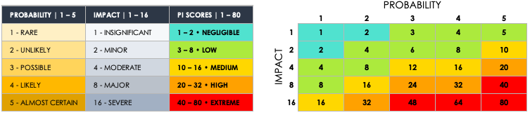
REF ID | DATE RAISED | RISK CATEGORY | RISK DESCRIPTION  (INCLUDING IF / THEN STATEMENT) | PROBABILITY  1 – 5 | IMPACT  1 – 16 | RISK SEVERITY SCORE  Prob x Impact | LIKELY TIMING OF RISK | RISK TRIGGER | MITIGATION / RESPONSE PLAN | STATUS OF MITIGATION / RESPONSE | OWNER | OTHER NOTES
 |  |  |  |  |  | 0
 |  |  |  |  |  | 0
 |  |  |  |  |  | 0
 |  |  |  |  |  | 0
 |  |  |  |  |  | 0
 |  |  |  |  |  | 0
 |  |  |  |  |  | 0
 |  |  |  |  |  | 0
 |  |  |  |  |  | 0
 |  |  |  |  |  | 0
DISCLAIMER

Any articles, templates, or information provided by Smartsheet on the website are for reference only. While we strive to keep the information up to date and correct, we make no representations or warranties of any kind, express or implied, about the completeness, accuracy, reliability, suitability, or availability with respect to the website or the information, articles, templates, or related graphics contained on the website. Any reliance you place on such information is therefore strictly at your own risk.

