VIDEO PRODUCTION GANTT CHART TEMPLATE

PROJECT NAME | PROJECT MANAGER | START DATE | END DATE
 |  | MM/DD/YY | MM/DD/YY

AT RISK | TASK NAME | STATUS | ASSIGNED TO | START  DATE | END  DATE | DURATION  in days | COMMENTS
 | Task 1 | Complete |  | MM/DD | MM/DD | 0
 | Task 2 | In Progress |  | MM/DD | MM/DD | 0
 |  | Not Started |  |  |  | 0
 |  | On Hold |  |  |  | 0
 |  | In Progress
 |  | Complete
 |  | On Hold

NOTE: To build out the chart portion below, please complete the chart data in the Excel Video Production Gantt Chart Template. A screenshot of the chart area can be captured and pasted into the Word version.

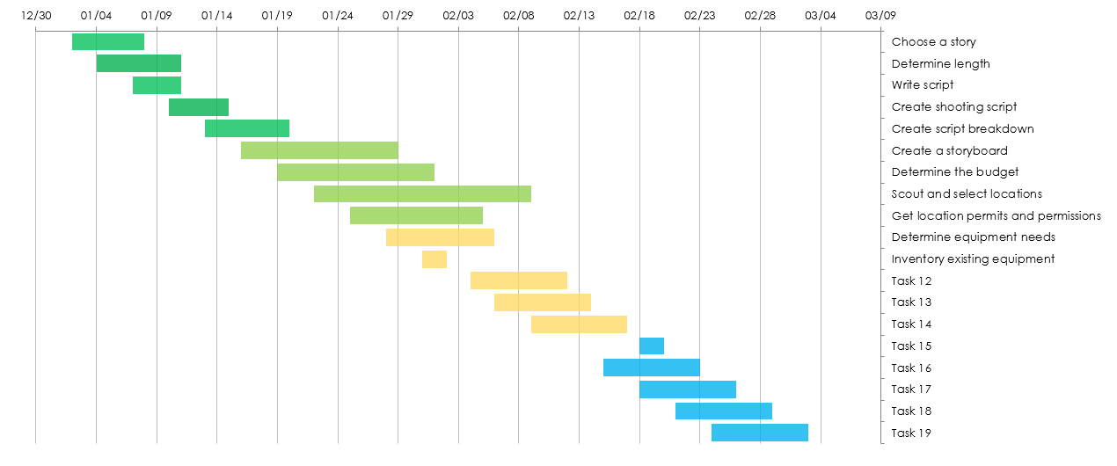

DISCLAIMER

Any articles, templates, or information provided by Smartsheet on the website are for reference only. While we strive to keep the information up to date and correct, we make no representations or warranties of any kind, express or implied, about the completeness, accuracy, reliability, suitability, or availability with respect to the website or the information, articles, templates, or related graphics contained on the website. Any reliance you place on such information is therefore strictly at your own risk.

