RISK AND OPPORTUNITY REGISTER – EXAMPLE

RISK DESCRIPTION | IMPACT DESCRIPTION | IMPACT  LEVEL | PROBABILITY LEVEL | PRIORITY LEVEL | OPPORTUNITIES | OWNER
Give a brief summary  of the risk. | What will happen if the risk  is not mitigated or eliminated? | Rate  1 (LOW) to  5 (HIGH) | Rate  1 (LOW) to  5 (HIGH) | ( IMPACT X  PROBABILITY )  Address highest first. | What opportunities do we have to lower or eliminate the impact or probability? | Who's responsible?
Material delivery is delayed | Production stops | 5 | 2 | 10 | Keep in contact with supplier, and alternative suppliers on retainer. | Hazel Christensen
Machinery breakdowns | Production delayed | 4 | 1 | 4 | Increase inspections.  Have spare parts on site. | Jason Desjardins
Leaks from roof during rain make the floor slippery | Slips and falls | 3 | 5 | 15 | – Order safety signage  – Have mops on hand  – Fix roof | Luiza Smith
Shortage of eye protection | – Increase in injuries  – Production delayed  – Increased premiums | 5 | 1 | 5 | – Increase supply  – Low inventory warnings  – Find alternative suppliers | Sheldon Greene
 |  | 5 | 5 | 25
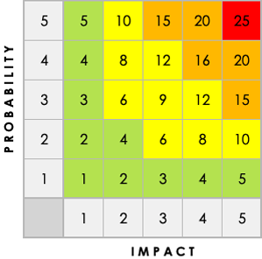

RISK AND OPPORTUNITY REGISTER TEMPLATE

RISK DESCRIPTION | IMPACT DESCRIPTION | IMPACT  LEVEL | PROBABILITY LEVEL | PRIORITY LEVEL | OPPORTUNITIES | OWNER
Give a brief summary  of the risk. | What will happen if the risk  is not mitigated or eliminated? | Rate  1 (LOW) to  5 (HIGH) | Rate  1 (LOW) to  5 (HIGH) | ( IMPACT X  PROBABILITY )  Address highest first. | What opportunities do we have to lower or eliminate the impact or probability? | Who's responsible?

DISCLAIMER

Any articles, templates, or information provided by Smartsheet on the website are for reference only. While we strive to keep the information up to date and correct, we make no representations or warranties of any kind, express or implied, about the completeness, accuracy, reliability, suitability, or availability with respect to the website or the information, articles, templates, or related graphics contained on the website. Any reliance you place on such information is therefore strictly at your own risk.

