CASE STUDY STORYBOARD TEMPLATE
for Microsoft Word EXAMPLE
This storyboard template allows you to create and present a visually engaging and narrative-based marketing case study that highlights each key phase with storytelling components.

INTRODUCTION SCENE
Welcome to Positive Charge, a pioneer in EV charging solutions, aiming to revolutionize urban mobility. Our mission: to make EV charging fast, accessible, and hassle-free. [Visual: A bustling cityscape with Positive Charge stations prominently featured.

CHALLENGE SCENE
The challenge: There were urban areas with insufficient EV charging infrastructure, leading to range anxiety among EV users. [Visual: Include a city map pinpointing sparse charging stations as well as images of worried EV drivers.

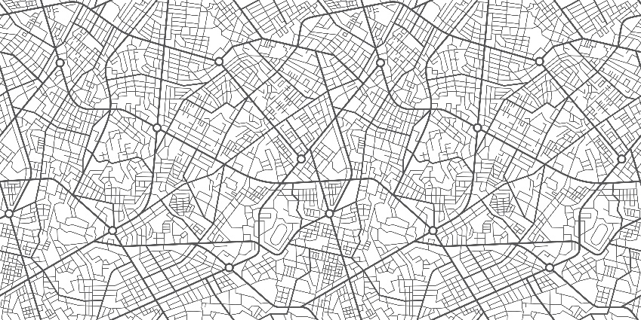

STRATEGY SCENE

Our strategy: We decided to deploy high-speed charging stations at strategic locations and launch an integrated marketing campaign targeting urban EV users. [Visual: Show the marketing team brainstorming, with campaign posters and digital ads in the background.]

IMPLEMENTATION SCENE

Implementation: We rolled out new charging stations with a vibrant launch event and digital marketing blitz. [Visual: Include images of teams setting up new stations and a social media campaign going live.]

RESULTS SCENE
Results: We experienced a 50% increase in station usage and a surge in customer satisfaction. [Visual: Display graphs showing growth in usage and positive customer feedback.]

CONCLUSION SCENE
Conclusion: Positive Charge's strategy successfully addressed the urban EV charging challenge, marking a milestone in sustainable urban transport. [Visual: Show a flourishing city with thriving Positive Charge stations.]

CALL-TO-ACTION SCENE
CTA: Join us in driving the EV revolution. Discover more about our solutions at Positive Charge. [Visual: Include an inviting image of a Positive Charge station with the website link.]

DISCLAIMER

Any articles, templates, or information provided by Smartsheet on the website are for reference only. While we strive to keep the information up to date and correct, we make no representations or warranties of any kind, express or implied, about the completeness, accuracy, reliability, suitability, or availability with respect to the website or the information, articles, templates, or related graphics contained on the website. Any reliance you place on such information is therefore strictly at your own risk.

