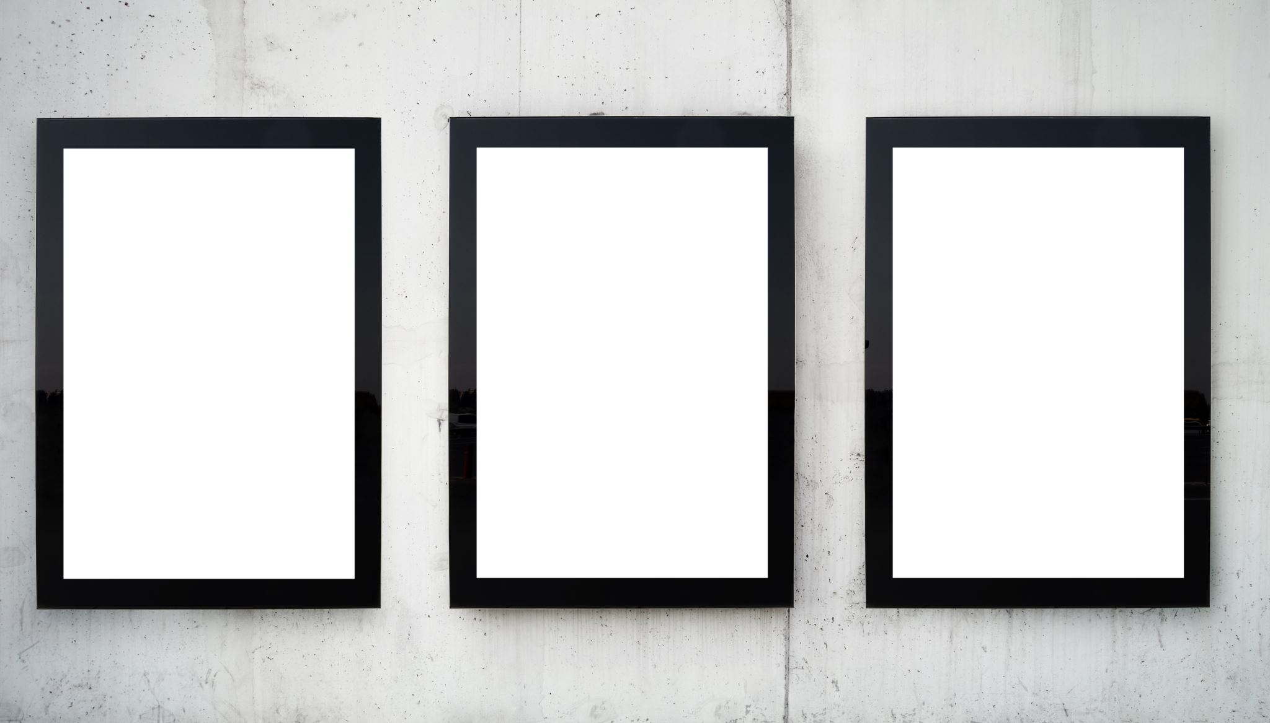
CASE STUDY STORYBOARD TEMPLATE
for Microsoft Word
This storyboard template allows you to create and present a visually engaging and narrative-based marketing case study that highlights each key phase with storytelling components.

INTRODUCTION SCENE

Set the scene with an introduction to your company, highlighting its unique value proposition and target market. Use illustrations to visually represent your brand and its positioning in the market.
Insert your own image or illustration.

CHALLENGE SCENE
Illustrate the primary marketing challenge or opportunity your company experienced. Examples include entering a new market, launching a product, or addressing a competitive threat. Use visuals to emphasize the magnitude or complexity of the challenge.

Insert your own image or illustration.
STRATEGY SCENE
Depict the marketing strategy you adopted to tackle the challenge. Include such tactics as campaign visuals, target audience personas, or key messaging. Highlight the creativity and thought processes behind the strategy.

Insert your own image or illustration.

IMPLEMENTATION SCENE
Show how the strategy was brought to life. Do this by including scenes portraying marketing campaigns in action, team collaborations, or customer interactions. Focus on the execution and deployment of your marketing tactics.

Insert your own image or illustration.
RESULTS SCENE

Present the outcomes of your marketing efforts. Use graphical illustrations to show increased sales, improved brand recognition, or other key metrics. This is where you demonstrate the impact of your marketing strategy.
Insert your own image or illustration.

CONCLUSION SCENE

Conclude with a summary of the case study. Reinforce the success of the marketing strategy and its learnings. Use a compelling visual that encapsulates the overall success story.
Insert your own image or illustration.
CALL-TO-ACTION SCENE
End with a clear call to action. This CTA could take the form of an invitation for the audience to learn more about your company, engage with your content, or consider your services. Use an arresting visual that prompts action.

Insert your own image or illustration.

DISCLAIMER

Any articles, templates, or information provided by Smartsheet on the website are for reference only. While we strive to keep the information up to date and correct, we make no representations or warranties of any kind, express or implied, about the completeness, accuracy, reliability, suitability, or availability with respect to the website or the information, articles, templates, or related graphics contained on the website. Any reliance you place on such information is therefore strictly at your own risk.

