
Basic Value Stream Map
Template
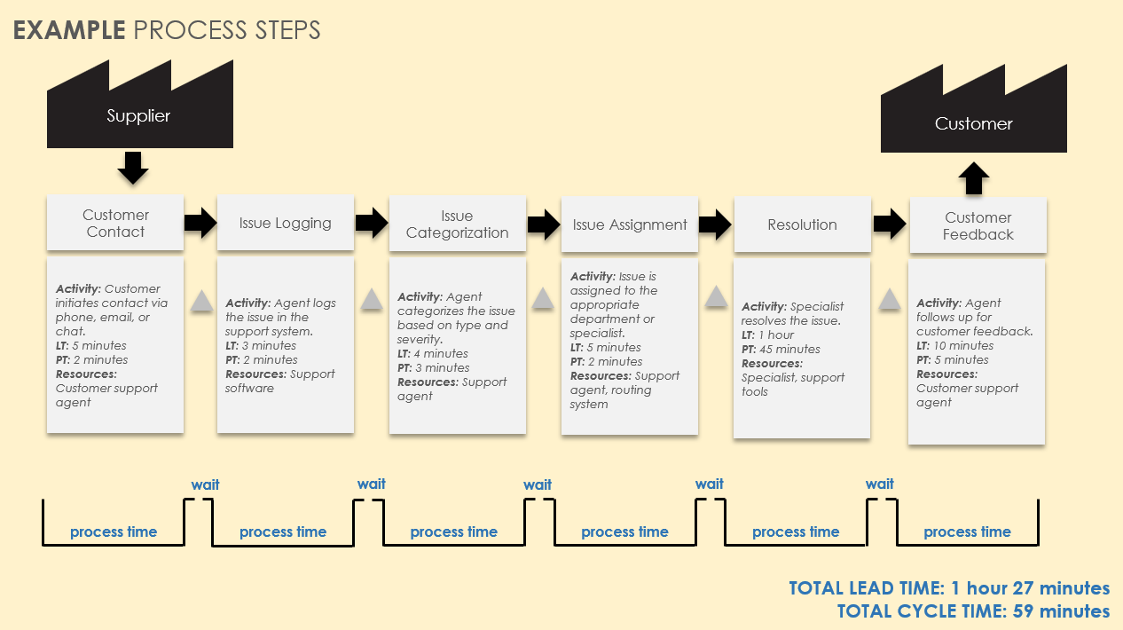
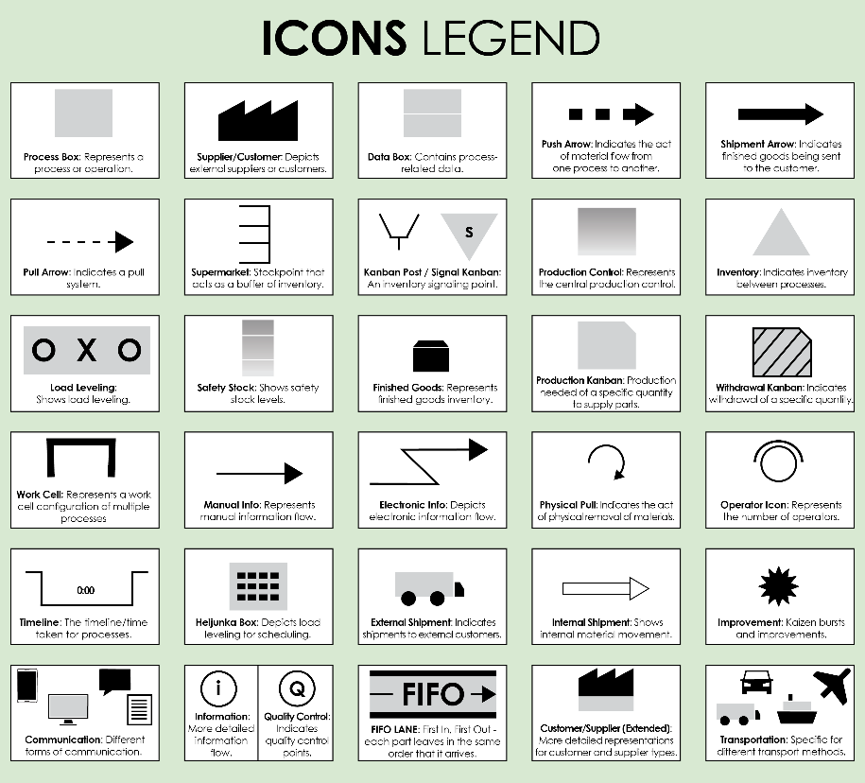
For descriptions, see VSM Icons Legend on Page 4 of this document.
To create your own VSM, copy and paste icons from the VSM Icons on Page 5 of this document.


To create your own VSM, copy and paste icons from the VSM Icons on Page 5 of this document.
Recommendations:
Bottlenecks:
NOTES
TITLE: Title here
Process Steps
TOTAL LEAD TIME: 0 hours 00 minutes
TOTAL CYCLE TIME: 0 hours 00 minutes

TITLE: Customer Support Process VSM
EXAMPLE Process Steps
Recommendations: Implement automated issue categorization and assignment to reduce lead times.
Bottlenecks: Issue assignment and resolution stages often face delays.
NOTES
TOTAL LEAD TIME: 1 hour 27 minutes
TOTAL CYCLE TIME: 59 minutes
wait
wait
wait
wait
wait
process time
process time
process time
process time
process time
process time
Customer Contact
Activity: Customer initiates contact via phone, email, or chat.
LT: 5 minutes
PT: 2 minutes
Resources: Customer support agent
Issue Logging
Activity: Agent logs the issue in the support system.
LT: 3 minutes
PT: 2 minutes
Resources: Support software
Issue Categorization
Activity: Agent categorizes the issue based on type and severity.
LT: 4 minutes
PT: 3 minutes
Resources: Support agent
Issue Assignment
Activity: Issue is assigned to the appropriate department or specialist.
LT: 5 minutes
PT: 2 minutes
Resources: Support agent, routing system
Resolution
Activity: Specialist resolves the issue.
LT: 1 hour
PT: 45 minutes
Resources: Specialist, support tools
Customer Feedback
Activity: Agent follows up for customer feedback.
LT: 10 minutes
PT: 5 minutes
Resources: Customer support agent
Supplier
Customer
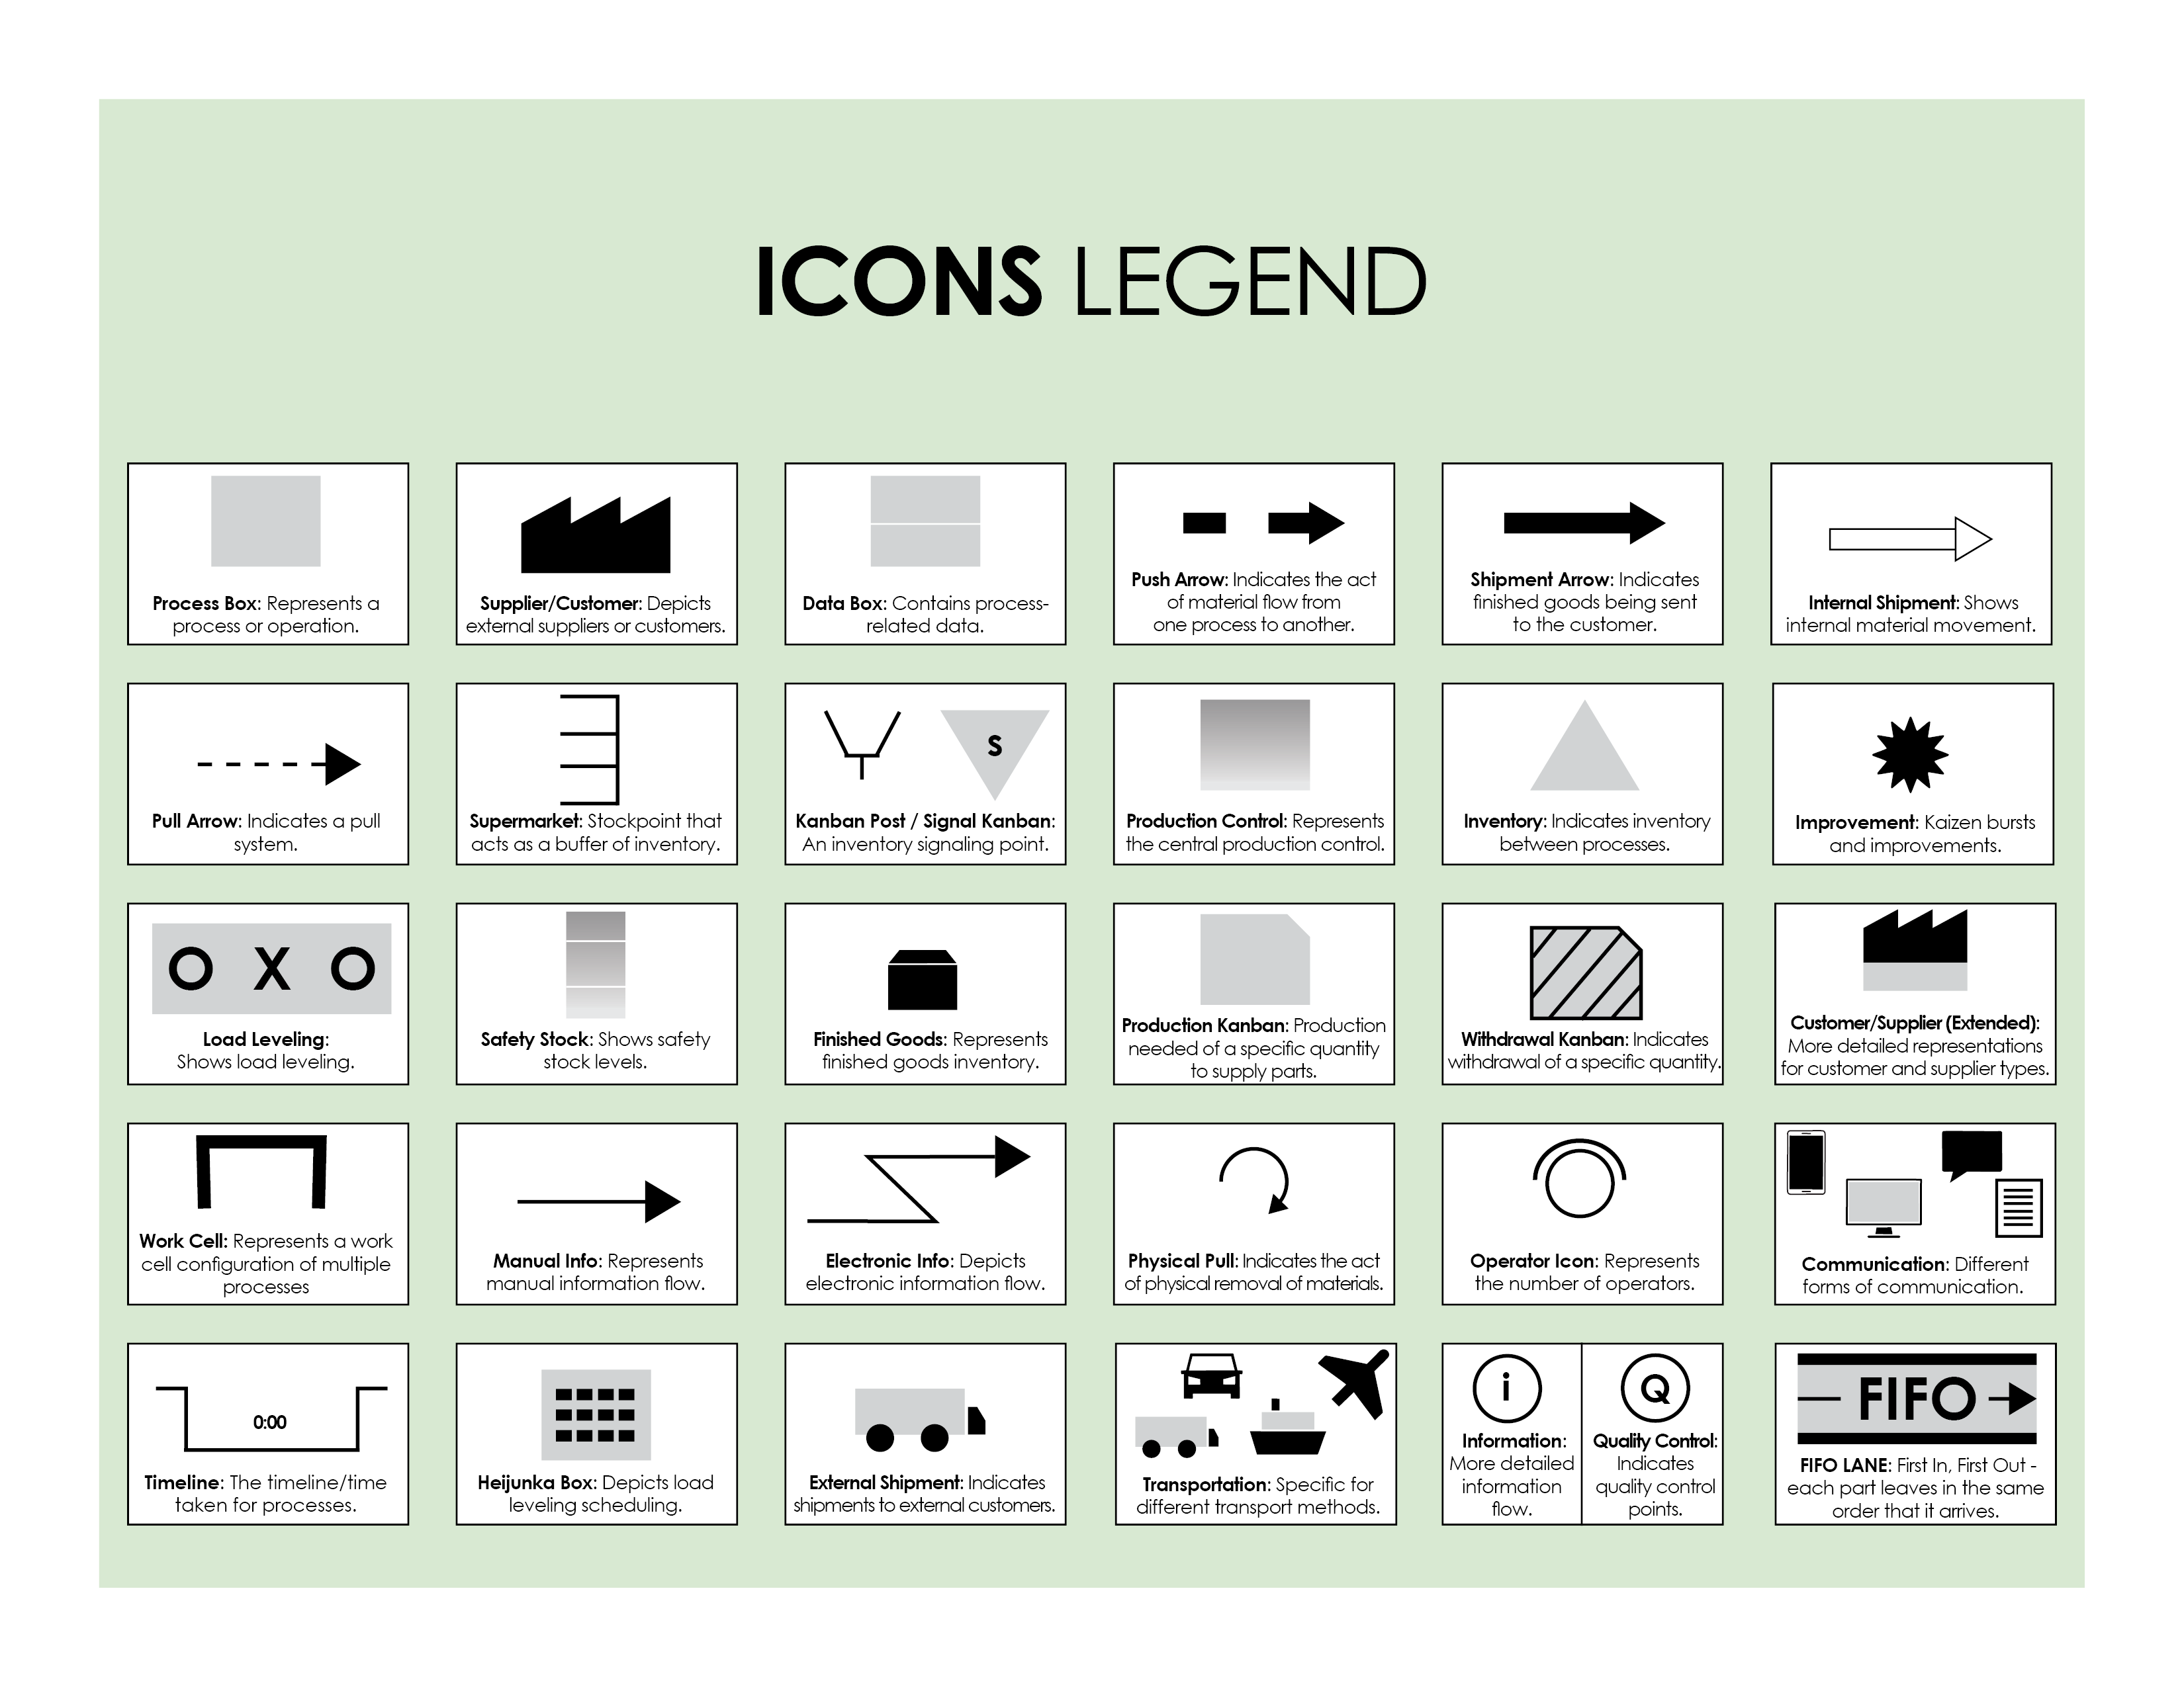

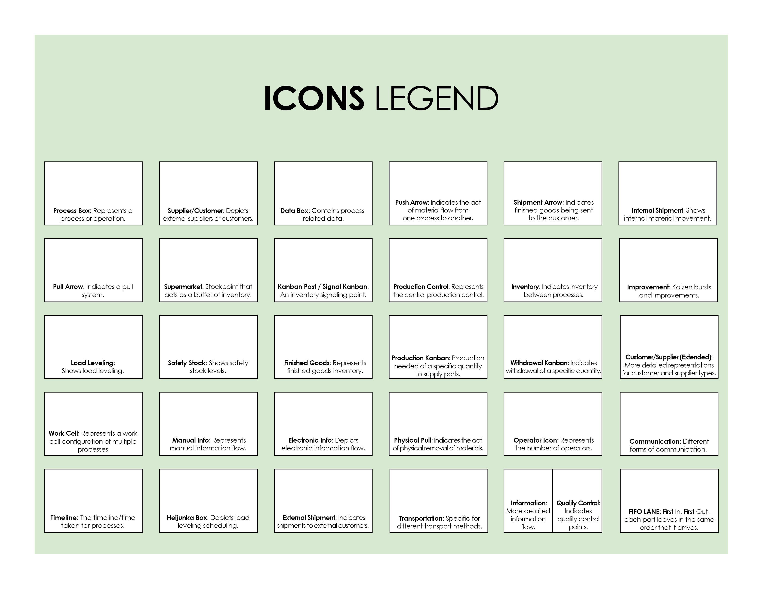
Copy and paste the icons below to create your own VSM.



DISCLAIMER

Any articles, templates, or information provided by Smartsheet on the website are for reference only. While we strive to keep the information up to date and correct, we make no representations or warranties of any kind, express or implied, about the completeness, accuracy, reliability, suitability, or availability with respect to the website or the information, articles, templates, or related graphics contained on the website. Any reliance you place on such information is therefore strictly at your own risk.

