
Lead Time Ladder VSM
Template

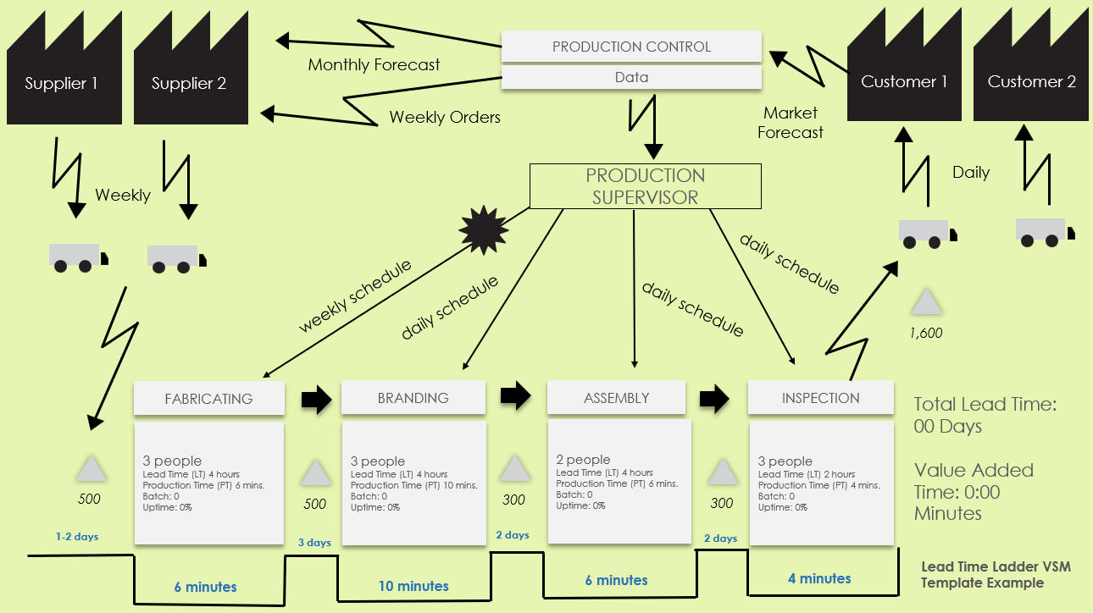

Use this map to illustrate and track lead times and cycle times across different stages to identify delays and areas for speed improvement.
For descriptions, see VSM Icons Legend on Page 4 of this document.
To create your own VSM, copy and paste icons from the VSM Icons on Page 5 of this document.

To create your own VSM, copy and paste icons from the VSM Icons on Page 5 of this document.
Lead Time Ladder VSM Template

PRODUCTION SUPERVISOR
Market Forecast
Lead Time Ladder VSM Template Example
Supplier 2
Supplier 1
2 days
2 days
1-2 days
3 days
6 minutes
Total Lead Time: 00 Days
Value Added Time: 0:00 Minutes
1,600
daily schedule
daily schedule
PRODUCTION CONTROL
Monthly Forecast
Weekly
INSPECTION
10 minutes
Data
ASSEMBLY
3 people
Lead Time (LT) 4 hours
Production Time (PT) 10 mins.
Batch: 0
Uptime: 0%
BRANDING
500
Customer 1
Daily
Customer 2
Weekly Orders
3 people
Lead Time (LT) 4 hours
Production Time (PT) 6 mins.
Batch: 0
Uptime: 0%
FABRICATING
500
300
6 minutes
2 people
Lead Time (LT) 4 hours
Production Time (PT) 6 mins.
Batch: 0
Uptime: 0%
300
3 people
Lead Time (LT) 2 hours
Production Time (PT) 4 mins.
Batch: 0
Uptime: 0%
4 minutes
weekly schedule
daily schedule
NOTES
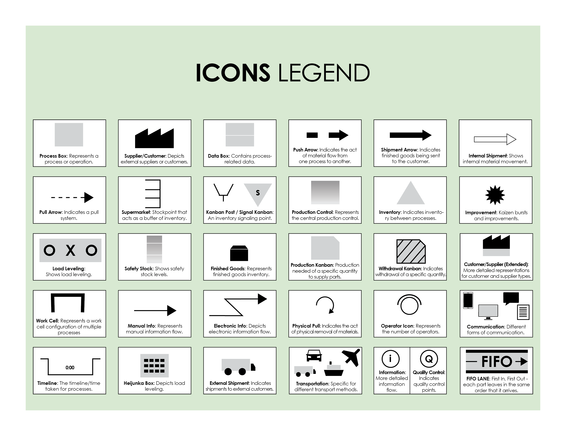


Copy and paste the icons below to create your own VSM.



DISCLAIMER

Any articles, templates, or information provided by Smartsheet on the website are for reference only. While we strive to keep the information up to date and correct, we make no representations or warranties of any kind, express or implied, about the completeness, accuracy, reliability, suitability, or availability with respect to the website or the information, articles, templates, or related graphics contained on the website. Any reliance you place on such information is therefore strictly at your own risk.

