
Value Stream Current State Map
Template Example

Use this map to illustrate the current state of a process flow, identify inefficiencies, and show where there is room for improvement in the workflow process.
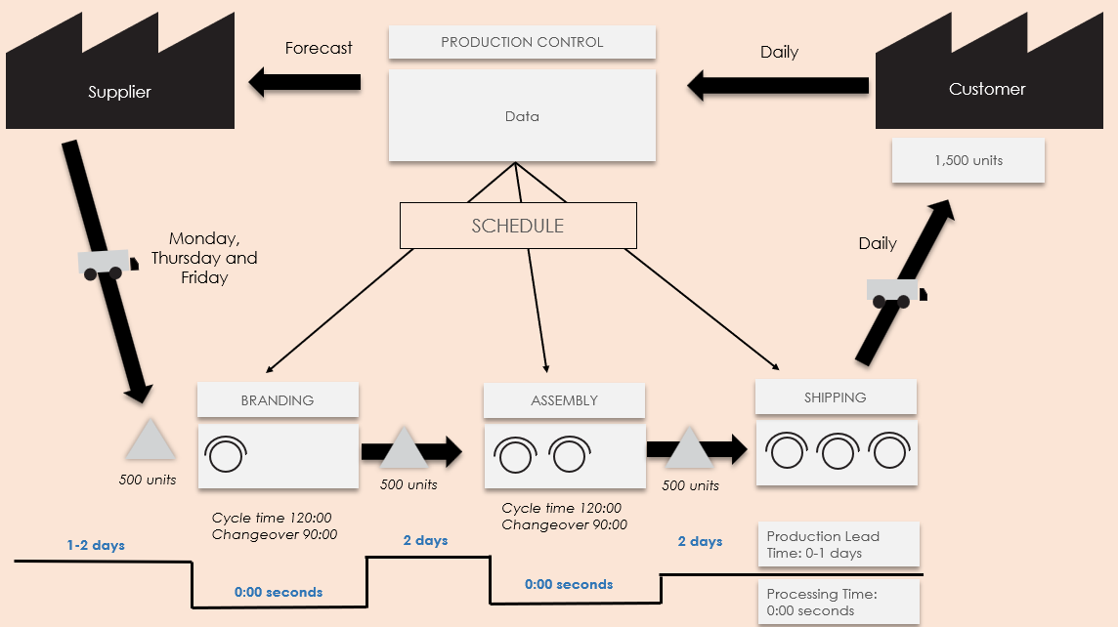
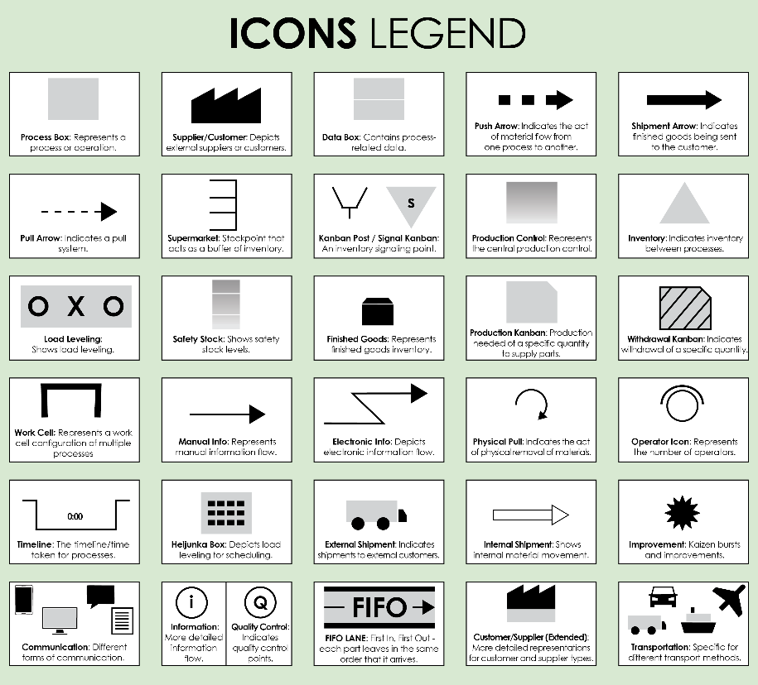
For descriptions, see VSM Icons Legend on Page 4 of this document.
To create your own VSM, copy and paste icons from the VSM Icons on Page 5 of this document.
Value Stream Current State Map Template Example
Forecast
500 units
500 units
500 units
Cycle time 120:00
Changeover 90:00
Cycle time 120:00
Changeover 90:00
0:00 seconds
0:00 seconds
Daily
Customer
Supplier
Processing Time:
0:00 seconds
2 days
Production Lead Time: 0-1 days
SCHEDULE
BRANDING
ASSEMBLY
1,500 units
Data
2 days
1-2 days
SHIPPING
Monday, Thursday and Friday
Daily
PRODUCTION CONTROL
NOTES
To create your own VSM, copy and paste icons from the VSM Icons on Page 5 of this document.
Value Stream Current State Map Template
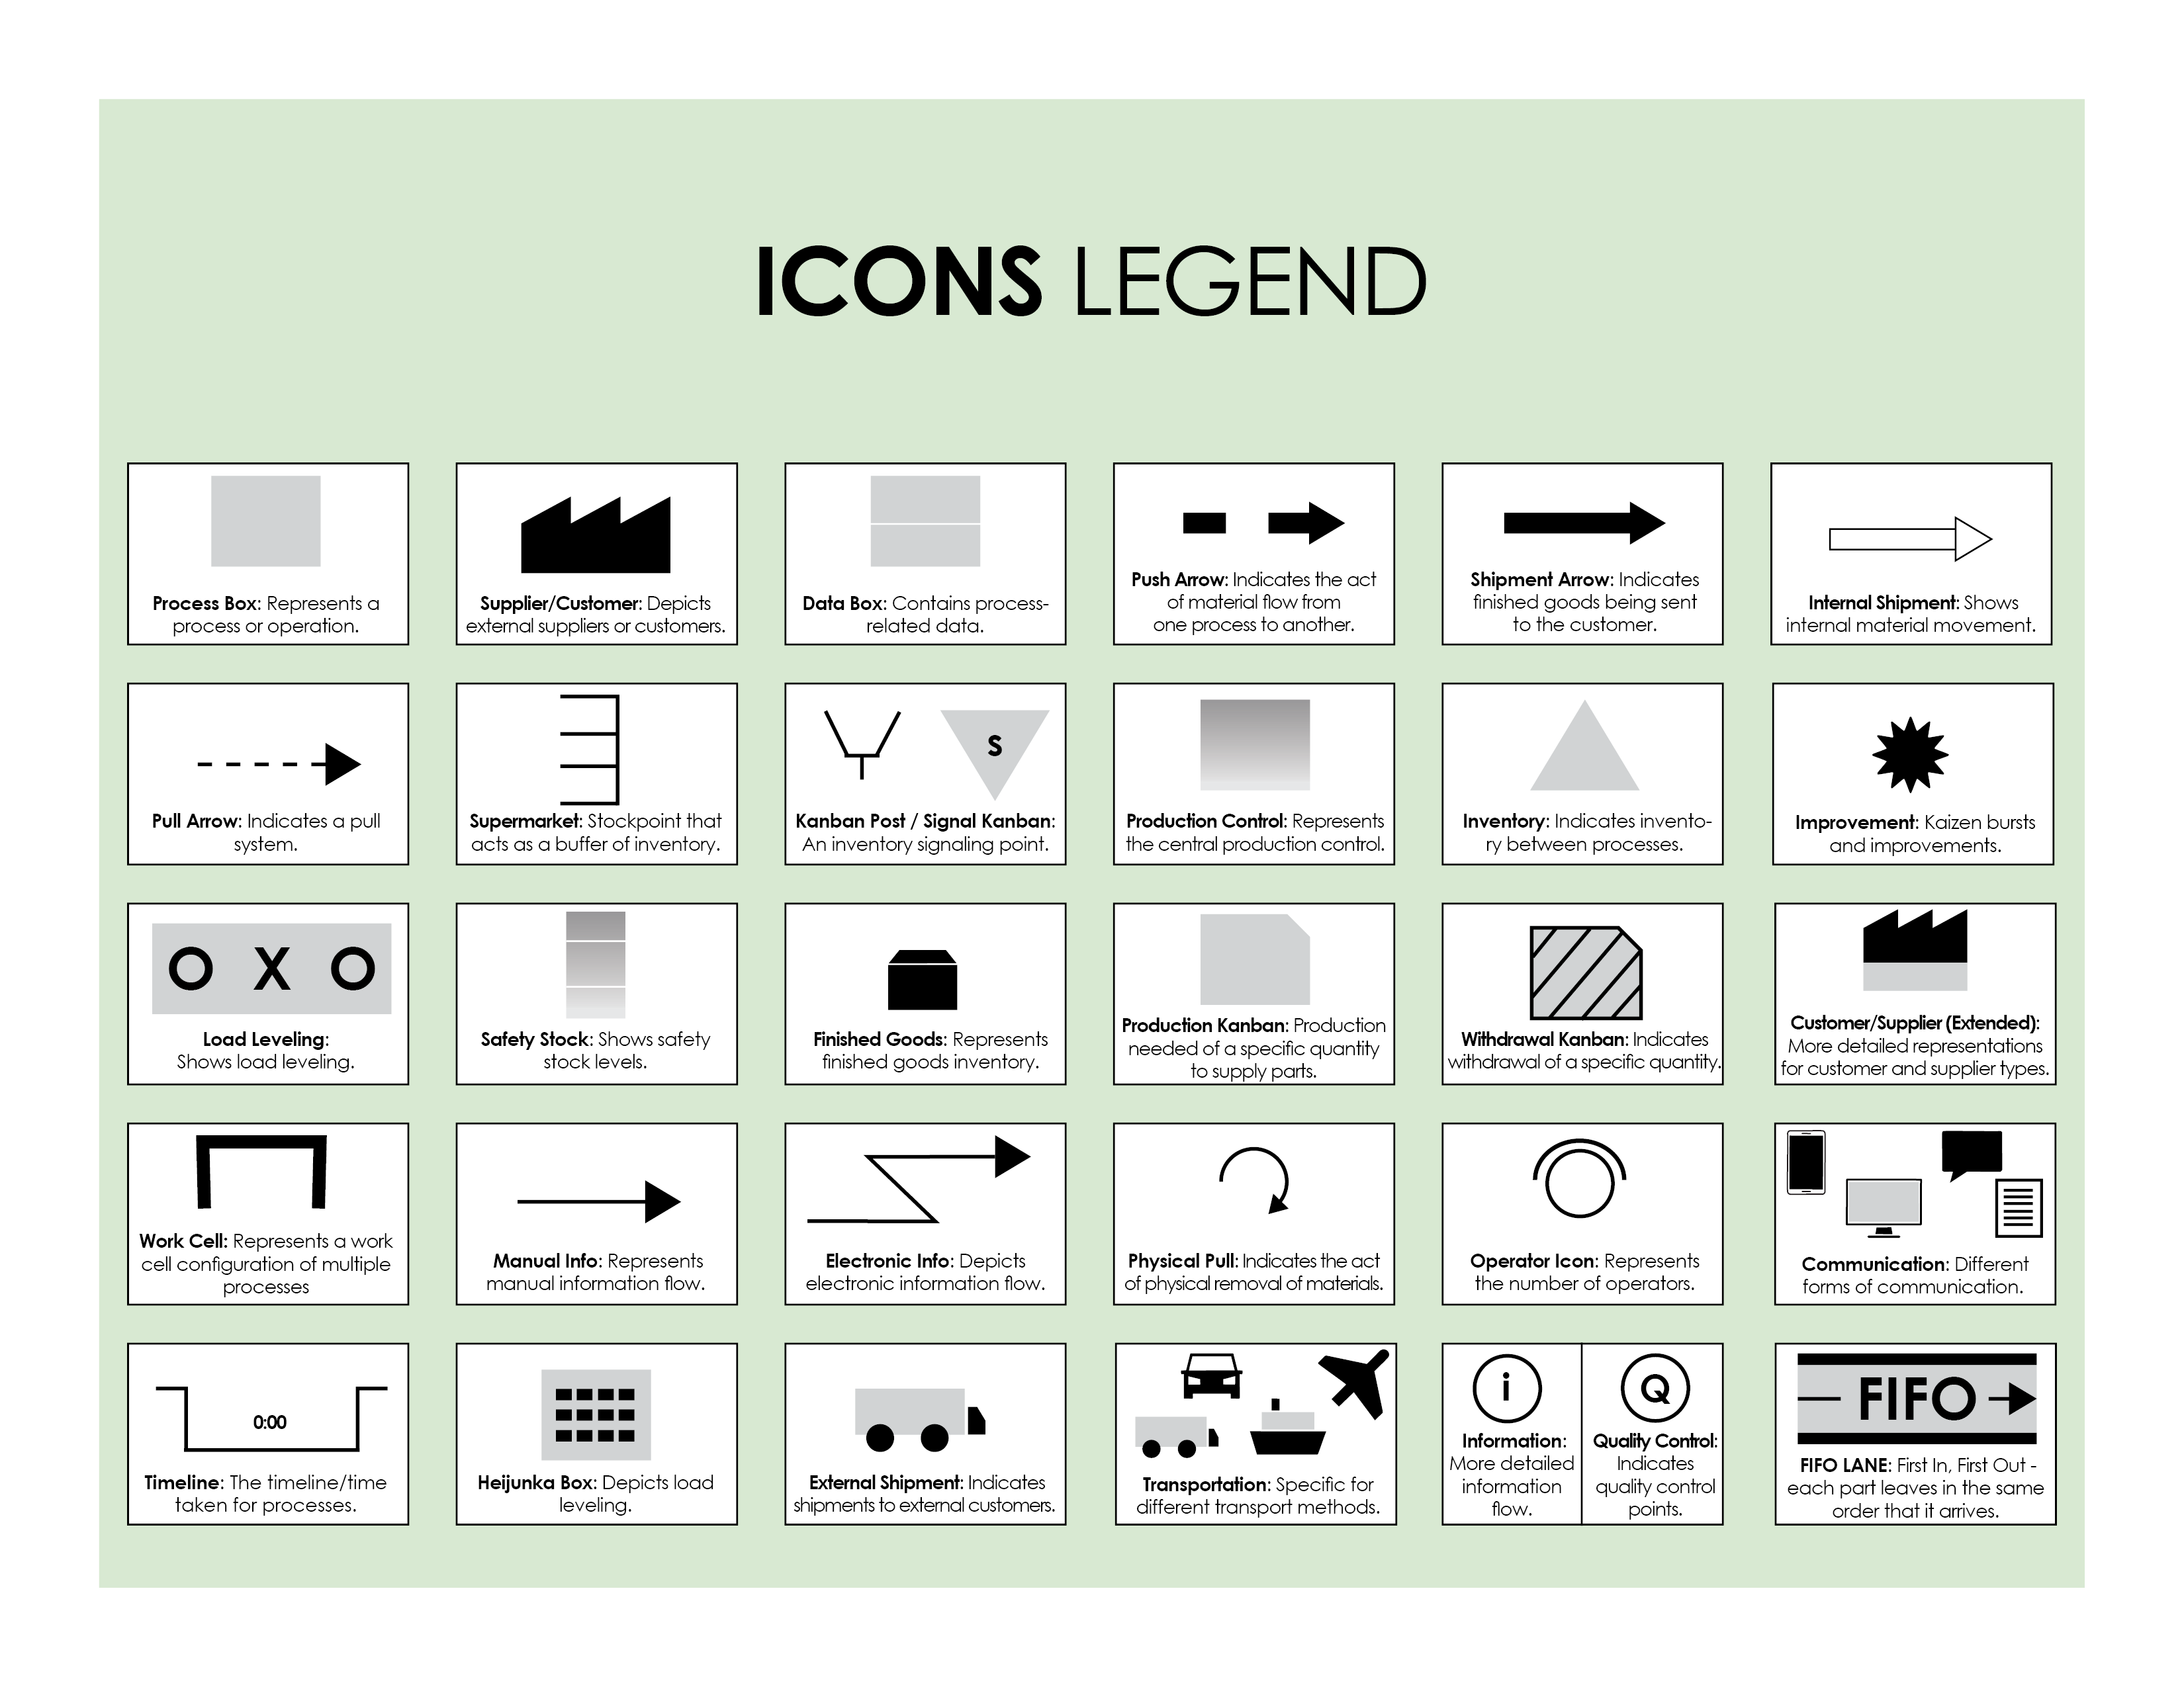

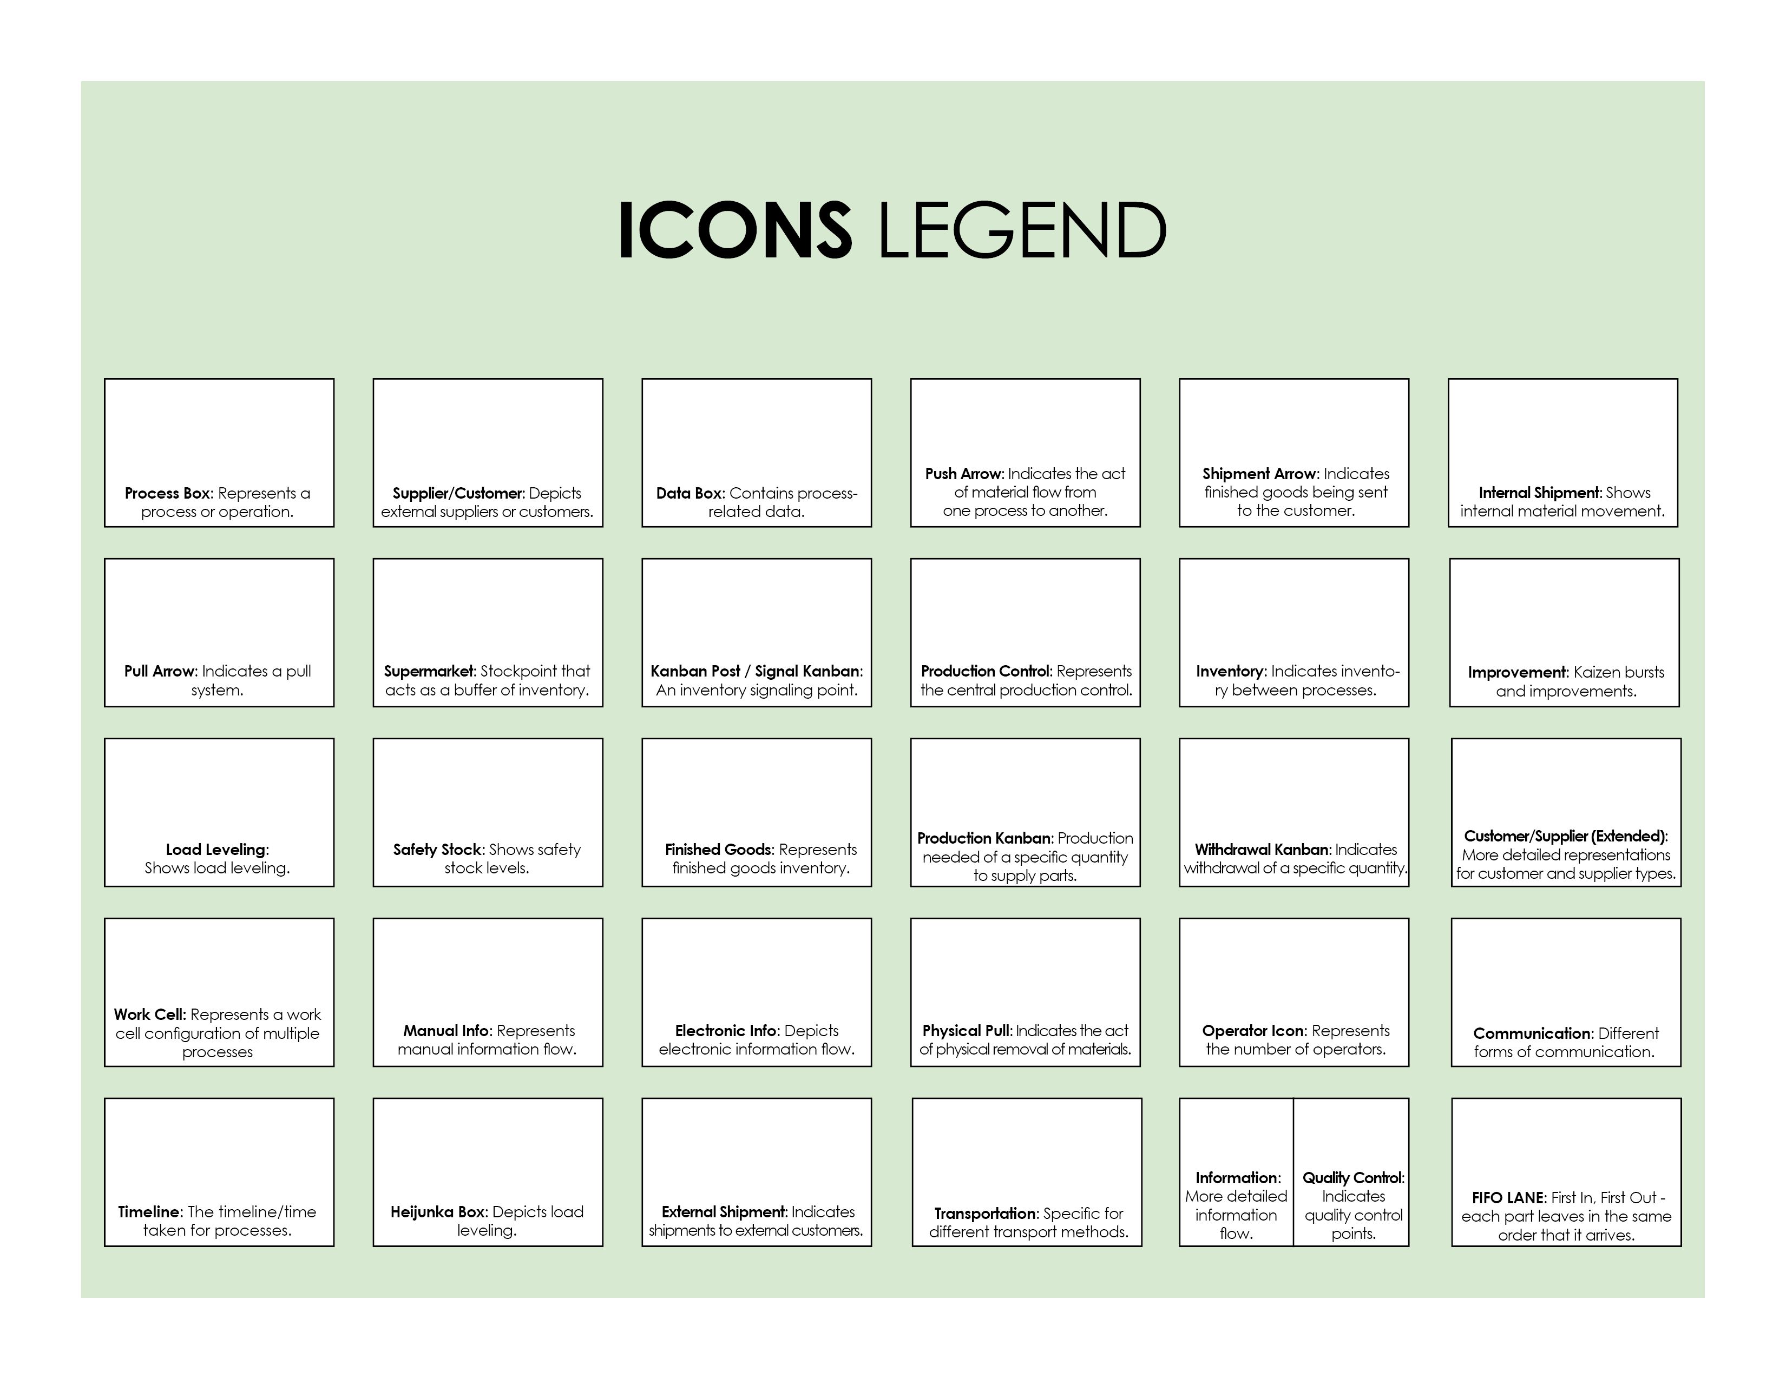
Copy and paste the icons below to create your own VSM.



DISCLAIMER

Any articles, templates, or information provided by Smartsheet on the website are for reference only. While we strive to keep the information up to date and correct, we make no representations or warranties of any kind, express or implied, about the completeness, accuracy, reliability, suitability, or availability with respect to the website or the information, articles, templates, or related graphics contained on the website. Any reliance you place on such information is therefore strictly at your own risk.

