
Value Stream Future State Map
Template

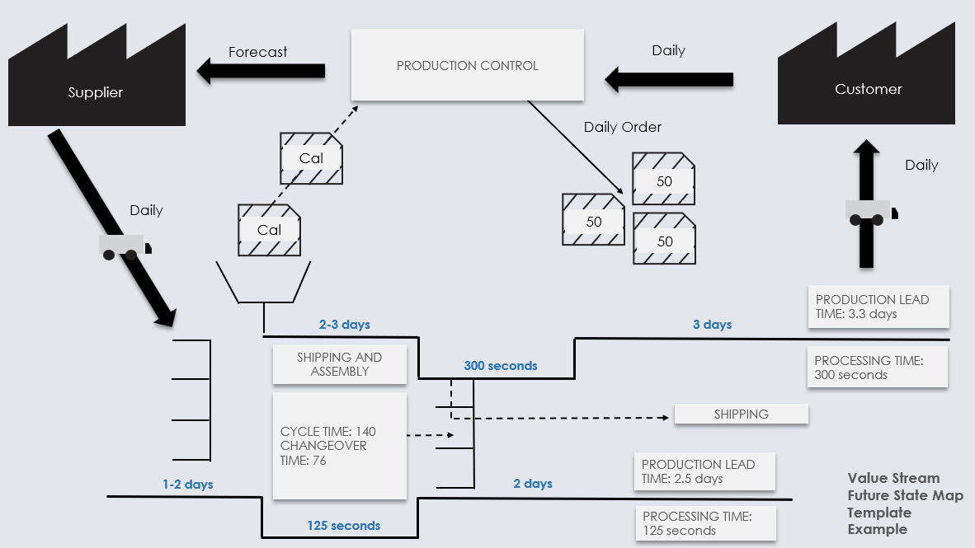
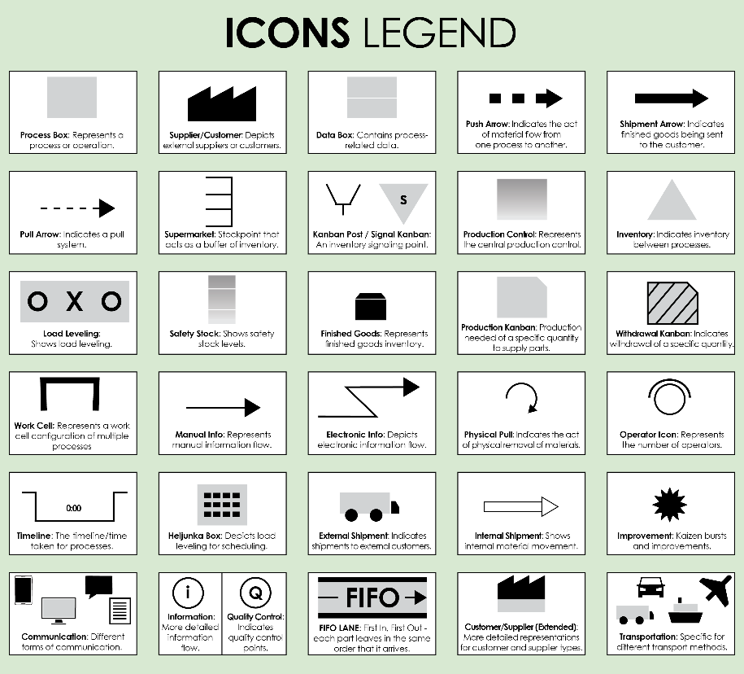
Use this map to visualize the ideal process flow after improvements and optimizations are implemented. This is to illustrate the "after."
For descriptions, see VSM Icons Legend on Page 4 of this document.
To create your own VSM, copy and paste icons from the VSM Icons on Page 5 of this document.

Value Stream Future State Map Template
To create your own VSM, copy and paste icons from the VSM Icons on Page 5 of this document.
Value Stream Future State Map Template Example
125 seconds
3 days
2 days
300 seconds
2-3 days
1-2 days
Daily
Forecast
Daily
Daily
Daily Order
PRODUCTION LEAD TIME: 3.3 days
PROCESSING TIME: 300 seconds
PRODUCTION LEAD TIME: 2.5 days
PROCESSING TIME: 125 seconds
SHIPPING AND ASSEMBLY
SHIPPING
Supplier
Customer
Cal
Cal
50
50
50
PRODUCTION CONTROL
CYCLE TIME: 140
CHANGEOVER TIME: 76
NOTES
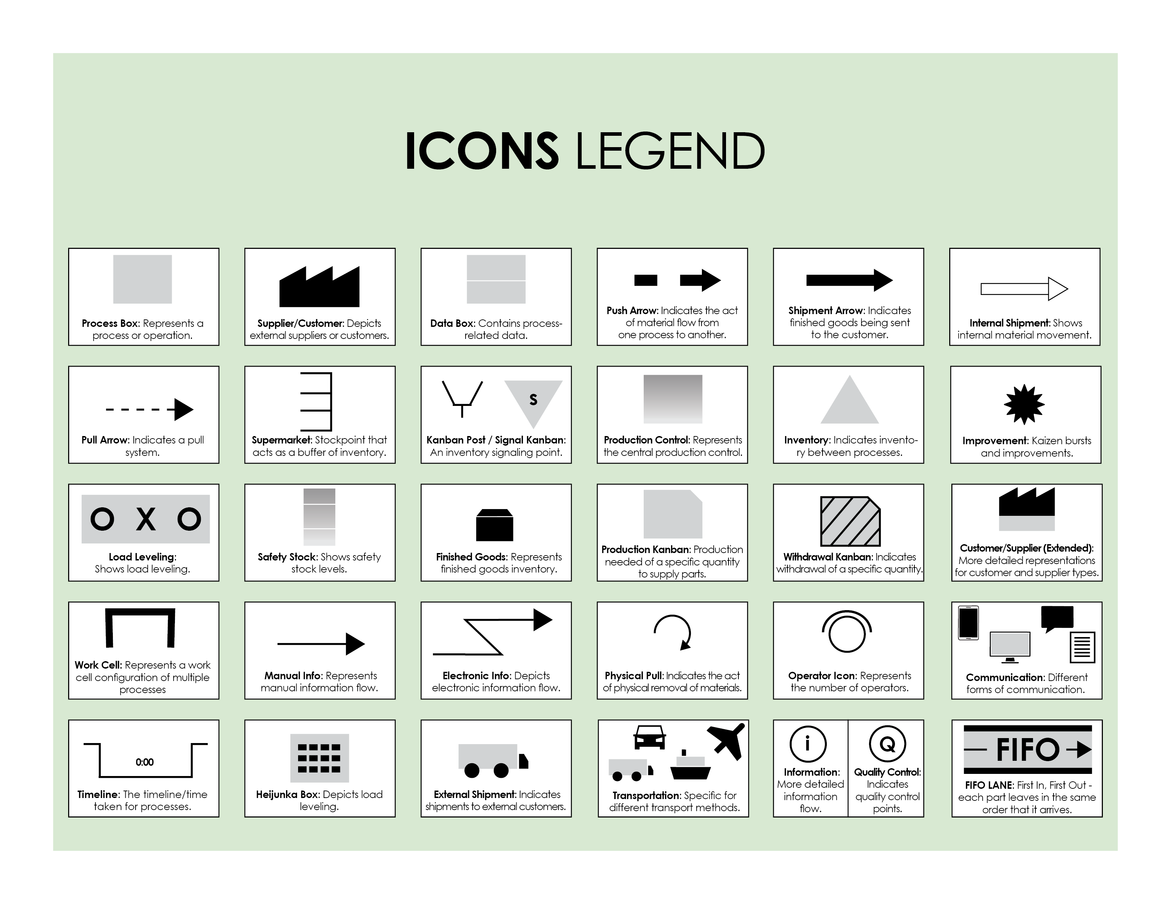

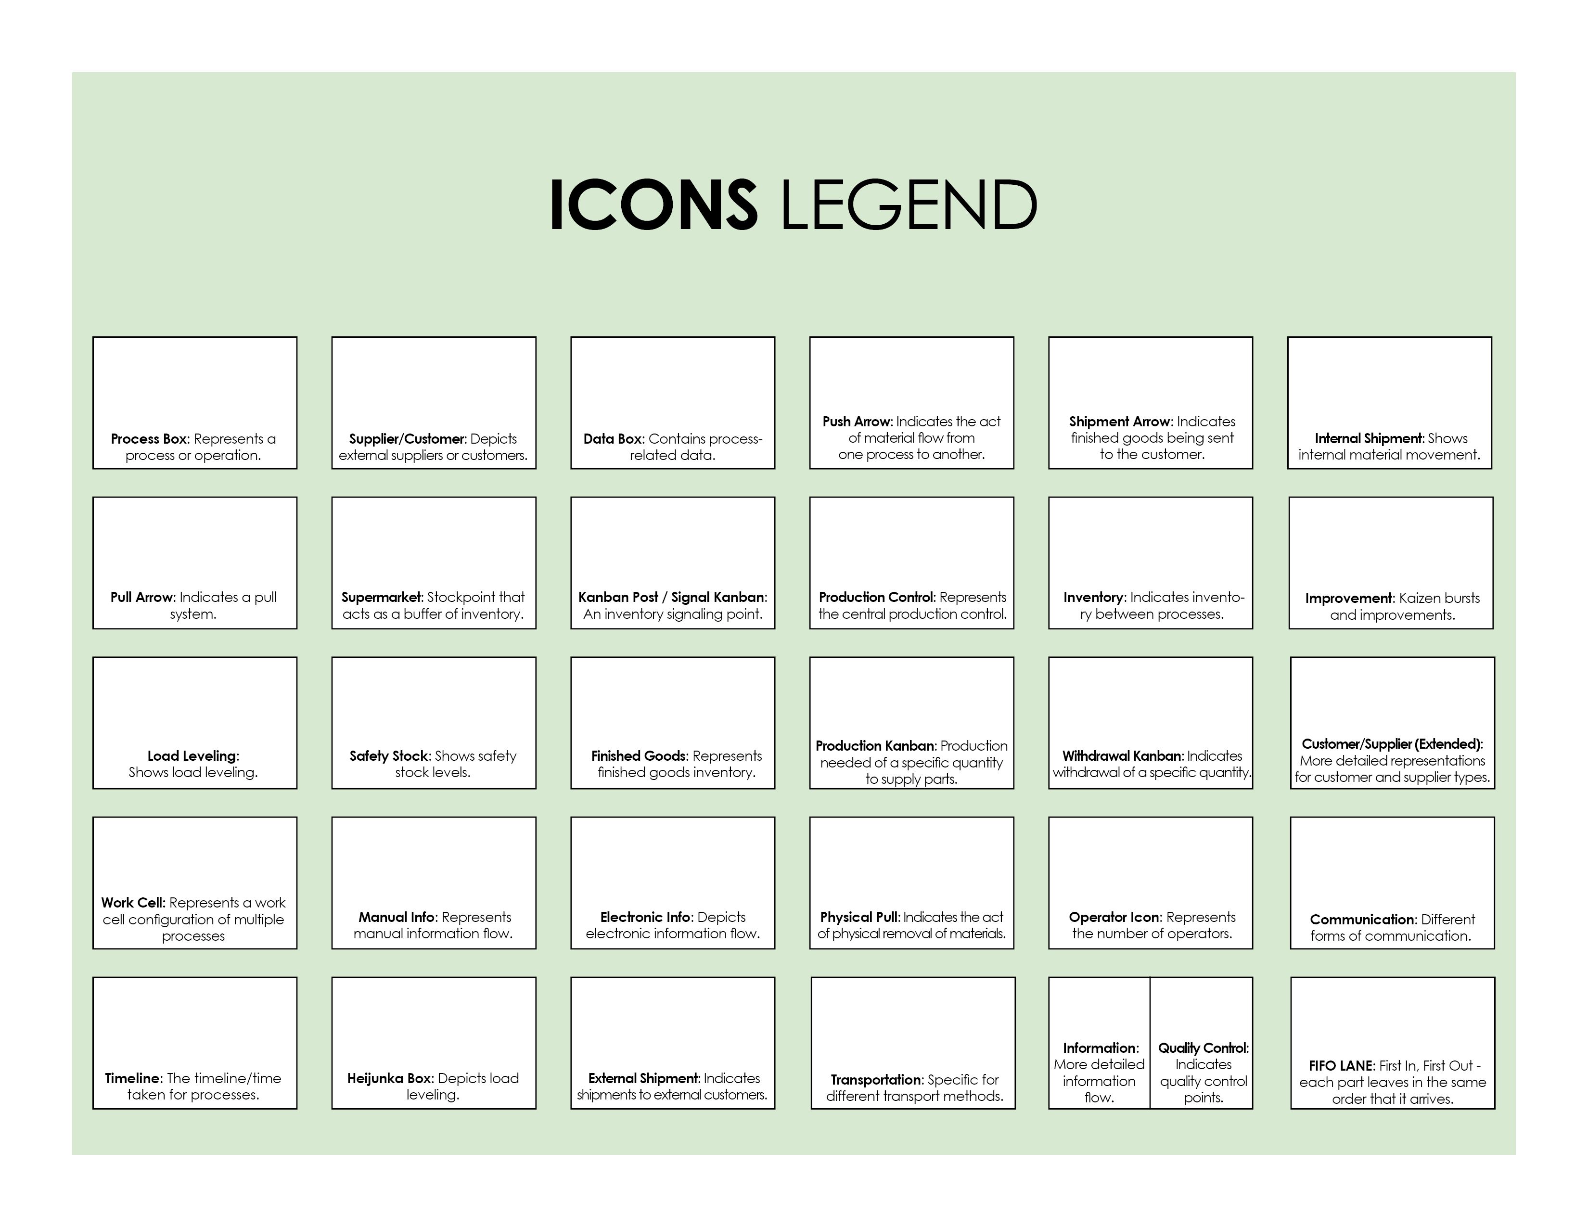
Copy and paste the icons below to create your own VSM.



DISCLAIMER

Any articles, templates, or information provided by Smartsheet on the website are for reference only. While we strive to keep the information up to date and correct, we make no representations or warranties of any kind, express or implied, about the completeness, accuracy, reliability, suitability, or availability with respect to the website or the information, articles, templates, or related graphics contained on the website. Any reliance you place on such information is therefore strictly at your own risk.

