
Hotel Pet Policy Template
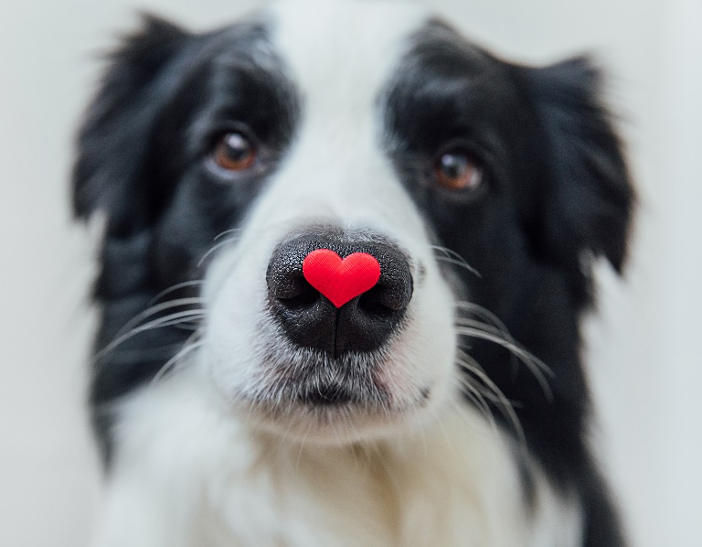
Hotel Name

Your Logo
Pet Policy

- Introduction
At [Hotel Name], we understand that pets are part of the family, and we welcome them in our designated pet-friendly rooms. To ensure a pleasant experience for all guests, we ask pet owners to adhere to the following policies.

- Pet Acceptance Agreement
Pet Types and Number
We allow a maximum of [number] pet(s) per room, limited to domesticated [species, e.g., dogs and cats] weighing no more than [weight limit] pounds each.
Vaccinations
All pets must be current on vaccinations. Proof of vaccination may be requested upon check-in.
Health and Behavior
Pets should be free of any contagious illnesses and exhibit non-aggressive behavior.

- Pet Fees
Non-Refundable Fee
A non-refundable fee of $[amount] per stay will be charged to cover additional cleaning.
Damage Deposit
A refundable damage deposit of $[amount] may be required at check-in. This deposit will be refunded upon satisfactory inspection of the room at check-out.
- Pet-Friendly Areas
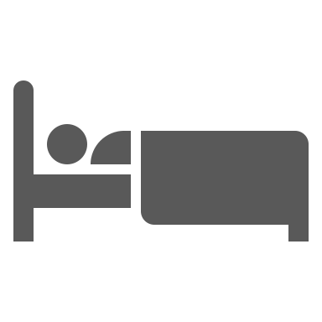 | Guest Rooms: Pets are permitted only in designated pet-friendly rooms.
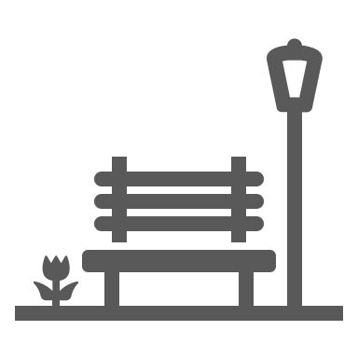 | Public Areas: Pets must be leashed or in a carrier and are allowed only in designated areas such as [list specific areas, e.g., lobby, outdoor patio]. Pets are not permitted in [list restricted areas, e.g., restaurant, pool area].
 | Pet Relief Areas: Please use the designated pet relief areas located [specify locations]. Owners are responsible for cleaning up after their pets.

- In-Room Guidelines
Unattended Pets
Pets should not be left unattended in guest rooms. If unavoidable, pets must be secured in a crate or carrier, and the "Pet in Room" sign should be displayed on the door.
Housekeeping
Housekeeping services will be provided only when pets are not present in the room. Please arrange a convenient time with the front desk.

- Owner Responsibilities
Noise Control
Owners must ensure that their pets do not disturb other guests. Excessive noise may result in additional charges or relocation.
Damage
Owners are responsible for any damage caused by their pets. Repair or replacement costs will be charged accordingly.
Cleanliness
Owners must clean up after their pets in both indoor and outdoor areas.

- Liability
[Hotel Name] assumes no responsibility for pets left unattended and is not liable for any injury or damage caused by pets. Owners agree to indemnify the hotel for any claims arising from their pet’s actions.

- Agreement
By signing below, I acknowledge that I have read and agree to abide by the [Hotel Name] Pet Policy.
Guest Name
Room Number
Pet(s) Name(s)
Signature
Date

DISCLAIMER

Any articles, templates, or information provided by Smartsheet on the website are for reference only. While we strive to keep the information up to date and correct, we make no representations or warranties of any kind, express or implied, about the completeness, accuracy, reliability, suitability, or availability with respect to the website or the information, articles, templates, or related graphics contained on the website. Any reliance you place on such information is therefore strictly at your own risk.

