
Microsoft Word
Land Surveying
Work Order
Template

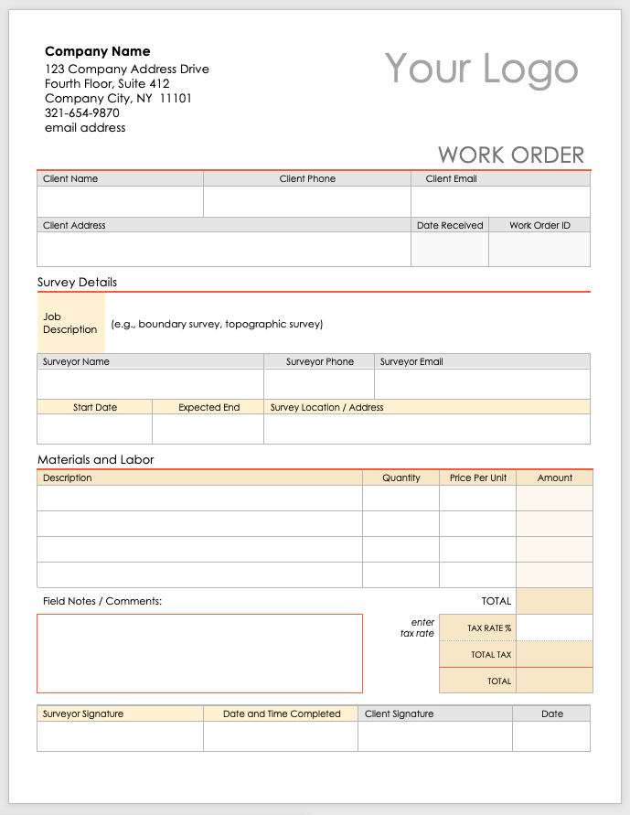
Company Name
123 Company Address Drive
Fourth Floor, Suite 412
Company City, NY 11101
321-654-9870
email address
Your Logo
WORK ORDER
Client Name | Client Phone | Client Email
Client Address |  | Date Received | Work Order ID
Survey Details
Job Description | (e.g., boundary survey, topographic survey)
Surveyor Name |  |  | Surveyor Phone | Surveyor Email
Start Date |  | Expected End | Survey Location / Address
Materials and Labor
Description |  |  | Quantity |  | Price Per Unit | Amount
Field Notes / Comments: |  |  |  |  | TOTAL
 |  |  |  |  | TAX RATE %
 |  |  |  |  | TOTAL TAX
 |  |  |  |  | TOTAL

Surveyor Signature | Date and Time Completed | Client Signature | Date

DISCLAIMER

Any articles, templates, or information provided by Smartsheet on the website are for reference only. While we strive to keep the information up to date and correct, we make no representations or warranties of any kind, express or implied, about the completeness, accuracy, reliability, suitability, or availability with respect to the website or the information, articles, templates, or related graphics contained on the website. Any reliance you place on such information is therefore strictly at your own risk.

