PROJECT RISK ASSESSMENT TEMPLATE

PROJECT ID | PROJECT NAME |  |  |  |  |  | PROJECT MANAGER

 |  |  | PRE-MITIGATION |  |  |  | POST-MITIGATION
REF / ID | ACTIVITY | RISK | RISK  SEVERITY | RISK LIKELIHOOD | RISK  LEVEL | MITIGATIONS / WARNINGS / REMEDIES | RISK  SEVERITY | RISK LIKELIHOOD | RISK  LEVEL | ACCEPTABLE  TO PROCEED?
 |  |  | – ACCEPTABLE  – TOLERABLE  – UNDESIRABLE  – INTOLERABLE | – IMPROBABLE  – POSSIBLE  – PROBABLE | – LOW  – MEDIUM  – HIGH  – EXTREME |  | – ACCEPTABLE  – TOLERABLE  – UNDESIRABLE  – INTOLERABLE | – IMPROBABLE  – POSSIBLE  – PROBABLE | – LOW  – MEDIUM  – HIGH  – EXTREME | YES / NO

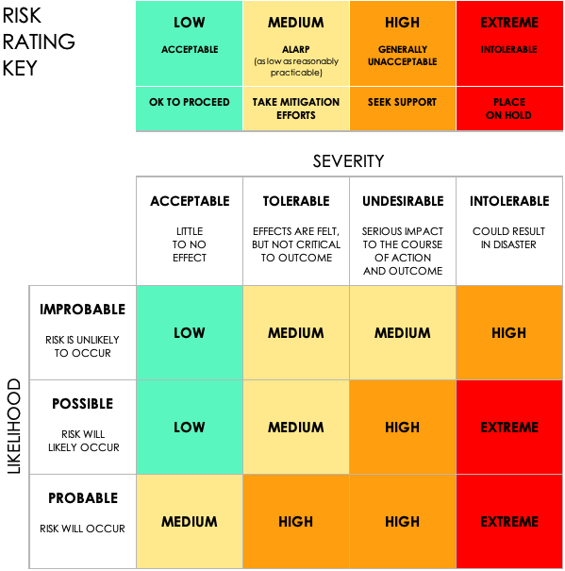

DISCLAIMER

Any articles, templates, or information provided by Smartsheet on the website are for reference only. While we strive to keep the information up to date and correct, we make no representations or warranties of any kind, express or implied, about the completeness, accuracy, reliability, suitability, or availability with respect to the website or the information, articles, templates, or related graphics contained on the website. Any reliance you place on such information is therefore strictly at your own risk.

