PROJECT TASK LIST WITH GANTT CHART TEMPLATE for Microsoft Word
PROJECT NAME | PROJECT MANAGER | START DATE | END DATE |  | OVERALL PROGRESS
Name | Name | MM/DD/YY | MM/DD/YY |  | 0%
PROJECT DELIVERABLE
SCOPE STATEMENT

TASKS | RESPONSIBLE | START | END | DAYS | STATUS
Task | Name | MM/DD | MM/DD | 0 | Complete
Task | Name | MM/DD | MM/DD | 0 | Complete
Task | Name | MM/DD | MM/DD | 0 | Complete
 |  |  |  |  | Overdue
 |  |  |  |  | In Progress
 |  |  |  |  | In Progress
 |  |  |  |  | Not Started
 |  |  |  |  | Not Started
 |  |  |  |  | Not Started
 |  |  |  |  | Not Started
 |  |  |  |  | Not Started
 |  |  |  |  | Not Started
Final Task |  | MM/DD | MM/DD | 0
NOTE: To build out the chart portion below, please complete the chart data in the Excel Project Task List with Gantt Chart Template. A screenshot of the chart area can be captured and pasted into the Word version.
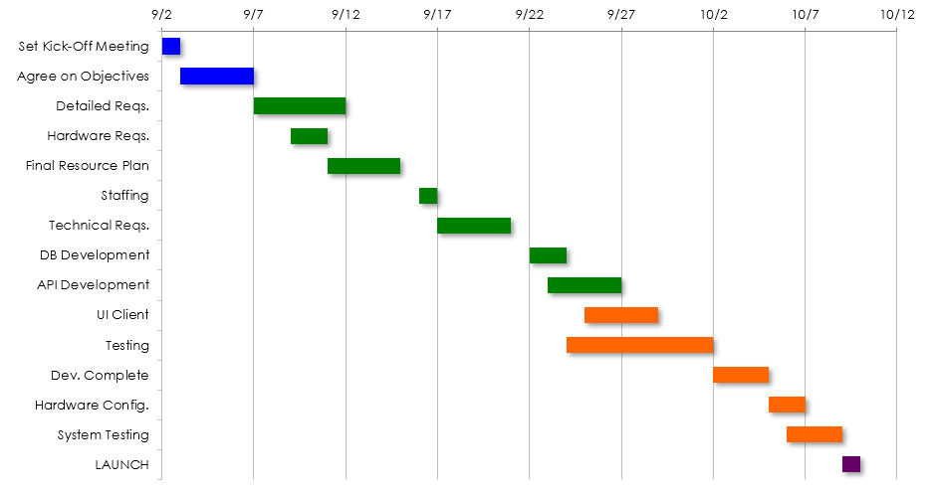

DISCLAIMER

Any articles, templates, or information provided by Smartsheet on the website are for reference only. While we strive to keep the information up to date and correct, we make no representations or warranties of any kind, express or implied, about the completeness, accuracy, reliability, suitability, or availability with respect to the website or the information, articles, templates, or related graphics contained on the website. Any reliance you place on such information is therefore strictly at your own risk.

